**UNIVERSITY OF ALASKA FAIRBANKS ART DEPARTMENT**

H&H

BFA Degree Thesis Exhibition Report

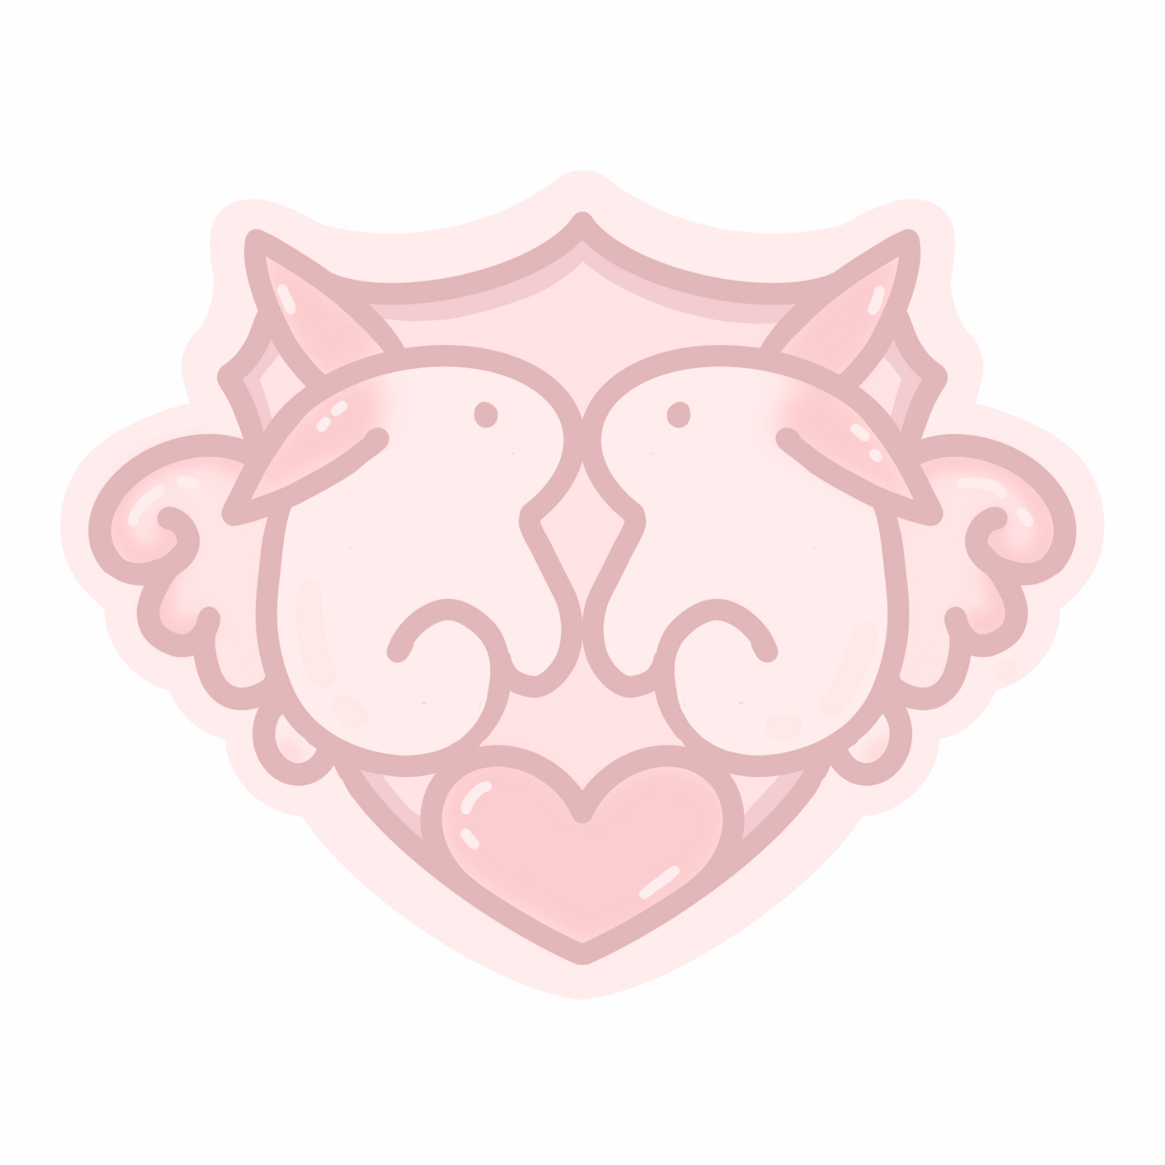

Presented to the BFA Degree Committee:

(Miho Aoki) (Zoe Marie Jones) (Sasha Blitzer) (Patricia Carlson)

**Marina Gonzalez Mazo**

04.01.2024

# BIOGRAPHY

I was born and raised in Logroño, Spain. I will graduate with a BFA from the University of Alaska Fairbanks in 2024. My main focus is jewelry, but I also do digital and multi-media artwork. My themes revolve around sexuality, death, and Catholic mysticism. I use my body as a reference for my work and to explore my inner world and feelings.

I only considered pursuing art as a career in my last year of high school. When I decided to follow along with my best friend and sign up for Art Bachiller*, I did it because I thought it would be fun to do arts and crafts with my best friend before studying a career in humanities in college. I never signed up to make it my profession, but after the first semester of classes started, I knew I couldn’t walk back to another branch that was not art.

That is where I was formed in plastic arts and art history basics. I learned to use cameras, chroma, and computer software for digital art. I got inspiration from past artists and shared ideas with my classmates about current trends and conceptual art. I further developed my art education at UAF, where I started exploring more materials and techniques, especially in the jewelry studio.

I have exhibited my work in galleries such as Wall Street Art Company and La Gota de Leche and journals like El Sol de Media Noche and Ice Box.

*\*(Spanish equivalent to the last two years of high school in America, but focusing on learning the basics of the subject that you want to study in college)*

# THESIS DESCRIPTION

**Concept and philosophy:**

I was born and raised in Spain. My hometown is in the middle of the pilgrimage to Santiago and near where the first Spanish words were written on paper. So, even if my family is not especially religious, Catholicism seeps into the cracks and crevices of our daily lives. Baptisms are done just to please the grandparents, and it's a perfect excuse to get all the family together to eat and drink for the whole night. I was surrounded by the grotesque and bloody figures of Semana Santa taking over the streets with their funeral marches, and I felt the drumrolls resonate in my ears while I walked to dinner with friends. Anywhere you turn a corner, there is a small chapel of a little saint, or you see teenagers getting drunk in front of the church: pop culture and biblical lowbrow get mixed everywhere.

As a young girl, I always felt like I didn't quite fit in. I constantly sought validation to boost my self-esteem and fill a void that I had felt since birth. To achieve this, I worked hard to be more approachable, open, and communicative with others. It wasn't until later that I became aware of the male gaze and the power it held in providing validation. I learned that by showing my body to someone who was desperate for it, I could maintain their interest and keep their validation coming.

When I started college, I had just turned 18, the age of the majority in Spain for most things. It is also when I felt safe to explore sex with other people. As much as I researched sex toys and fantasies and practiced masturbation before even becoming a teenager, I had never had the nerve to try to have sex with another person before turning eighteen. I did not trust myself enough to do it safely (or to find someone my age who would have done as much research as I had done) until I was officially a grown-up. Something in my mind was shaming me from wanting to do it before I was a grown-up.

I had no peers in high school to whom I could talk openly about sex and my fantasies. But then it became a taboo subject (or at least I felt I had to be extra careful about who I was talking to) in college in the States. The culture shock and how different Christianity is in the United States had me feel like I couldn’t fit in at all.

If I had to pinpoint the moment where the low self-esteem, impostor syndrome, high libido, and a disdain for purism culture got all together in the mixing pot inside my brain, it would be during my first year of college. I felt I wasn't doing enough, but at the same time, I wasn't getting enough from my classes and my career. This was also the time when I felt the most disapproval about sexuality around me (because of the cultural shock). This is when all the negative feelings from high school resurfaced, the “I'm not enough” and “I am letting everyone down.” People expected excellence, but I was barely surviving. The only thing that I could safely rely on for validation was my body. Now that I was legally overage and my body had matured, I used it to try to feel accepted and loved.

It turned very dark very quickly. I unconsciously started to use the rush and adrenaline of sex as a way to cope with the anxiety that the void produces. This led me to eventually have sex practices that were done only for self-harm purposes, and I did not notice until way later. I justified saying that “I am not hurting anybody” and “I know my value” while simultaneously posting nudes to please chronically online men so that I could have a couple of poorly written and very gross compliments written in the comments. I felt so gross doing it, but that was what I wanted. I wanted to feel bad. I found the most effective way to do self-harm and disguised it with a need to seek validation, a perfect plan. I felt Just like a saint, providing miracles to desperate men and martyrizing myself afterward.

I just want to love myself. And no matter how much people around me love, desire, or support me, I know it must be me who fixes my sadness. So this show is a fever-induced sexual dream of me coming to terms with my sexuality, my self-harm tendencies, and knowledge of how pathetic I am sometimes, but recognizing myself as the goddess I ought to be to be strong enough to close the curtains for this act and reach my full potential on the next chapter.

MAIN THEMES:

**H&H:**

The acronym for "Holy and Horny" or "Holyness and Horniness" is represented by the title "H." Interestingly, this letter is also used to denote "hentai" on certain manga websites. The decision to use just the letter "H" was deliberate, as it added an element of intrigue and symmetry. Additionally, the title was often accompanied by a coat of arms, further enhancing the perception of a secret society or cult.

**Bunny:**

She is a sexual alter ego. She presents as an easy prey to trick people into consuming her, which feeds her ego. She has at least a reason to feel bad if she hurts herself.

**Color palette:**

The color palette is dominated by baby pink. I used to hate pink, but I still do a little. Something about not wanting to be associated with “girly,” fragile, and weak things. However, boys also used pink once, as it is related to red. So pink is now, for me, the color of washed blood. White is also one of the main colors, and it is used to signify purity. Black appears in accents, like the frames or the pattern of the cloth. Gold is another accent that compliments the jewelry. Finally, there are very few splashes of blue to oppose the pink, and that lets us view the real bunny in the real world (saint self, orphic window)

**A multy media inmersion:**

The gallery and the work are arranged to follow a traditional Gothic church floor plan. The main wall and altar table are reserved for the head of the gallery. On the sides, there are smaller altars. There is a rosette window to mimic the rosettes from the facades of the churches. The curtains on the walls help separate the space and give it a more architectural feel. The decorations that define the space as a temple are the candles, repeated iconography, and flowers. The goal is to make the spectator feel they are stepping inside a small sanctuary. After the opening day, some people commented on how much it looked like a little girl's room.

**Self-harm, religious flagellation, and BDSM:**

Flagellation is a form of penance within the Catholic Church. It is usually seen as a means to keep the mind on track and punish the flesh. “But I punish my body and enslave it, so that after proclaiming to others I myself should not be disqualified.” 1 Corinthians 9:27 (NRSV).

There are infinite ways to do self-harm, and the BDSM restraints of the show are just a way to convey confinement so Bunny can not do anything wrong. The real self-harm that is being done is the exhibitionism done for toxic internet communities. It's not very different than doing it to please a god. “Serving to the male gaze” to feel loved and expire the guilt I feel constantly for not being enough. Hurting the mind and punishing the body. No one else needs to do it since I will be the first to discipline me.

**Influences:**

The floor plan of European churches is a prominent influence on the show's concept and philosophy. I drew inspiration from a variety of contemporary artists working in different mediums for my show's content and concept.

One such artist is Marina Salazar, a Spanish art director whose work centers around upcycling religious or otherwise figurines into pop-culture sculptures. Her use of pastel colors and sexual themes is well-known.

Isa Muguruza, a Spanish illustrator, creates images with a vaporwave aesthetic that explores the body and sexuality. While also utilizing pastels, she is not afraid to incorporate more saturated colors into her work.

Kabi Nagata, a Japanese mangaka, inspired me with her autobiographical work "My Lesbian Experience with Loneliness." Her exclusive use of pastel pinks, white, and black in her narrative explores her traumas and perceptions of herself during early adulthood, including self-harm tendencies and intrusive thoughts.

Finally, Megumi Igarashi (also known as Rokudenashiko), a Japanese Sculptor and mangaka, creates art that features female genitalia, often her own. Her small dioramas, made from a cast of her vulva and decorated as daily scenery, are some of my favorite pieces.

ARTWORK:

# V DEL COÑO

This rosary is fabricated with sterling silver and beads. The pearls are strung and knotted together with nylon rope. The Silver piece is a combination of lost wax casting and fabrication techniques. The figurine was modeled in wax, cast, and cleaned. Then, it is soldered into an almond aura cut out from a silver sheet and filled to create the volumes of the light rays.

The Virgin Mary is a symbol of purity, and that purity does not need to be defined solely as keeping chastity. This piece speaks to a healthy and educational sexual education and approach to sexuality. 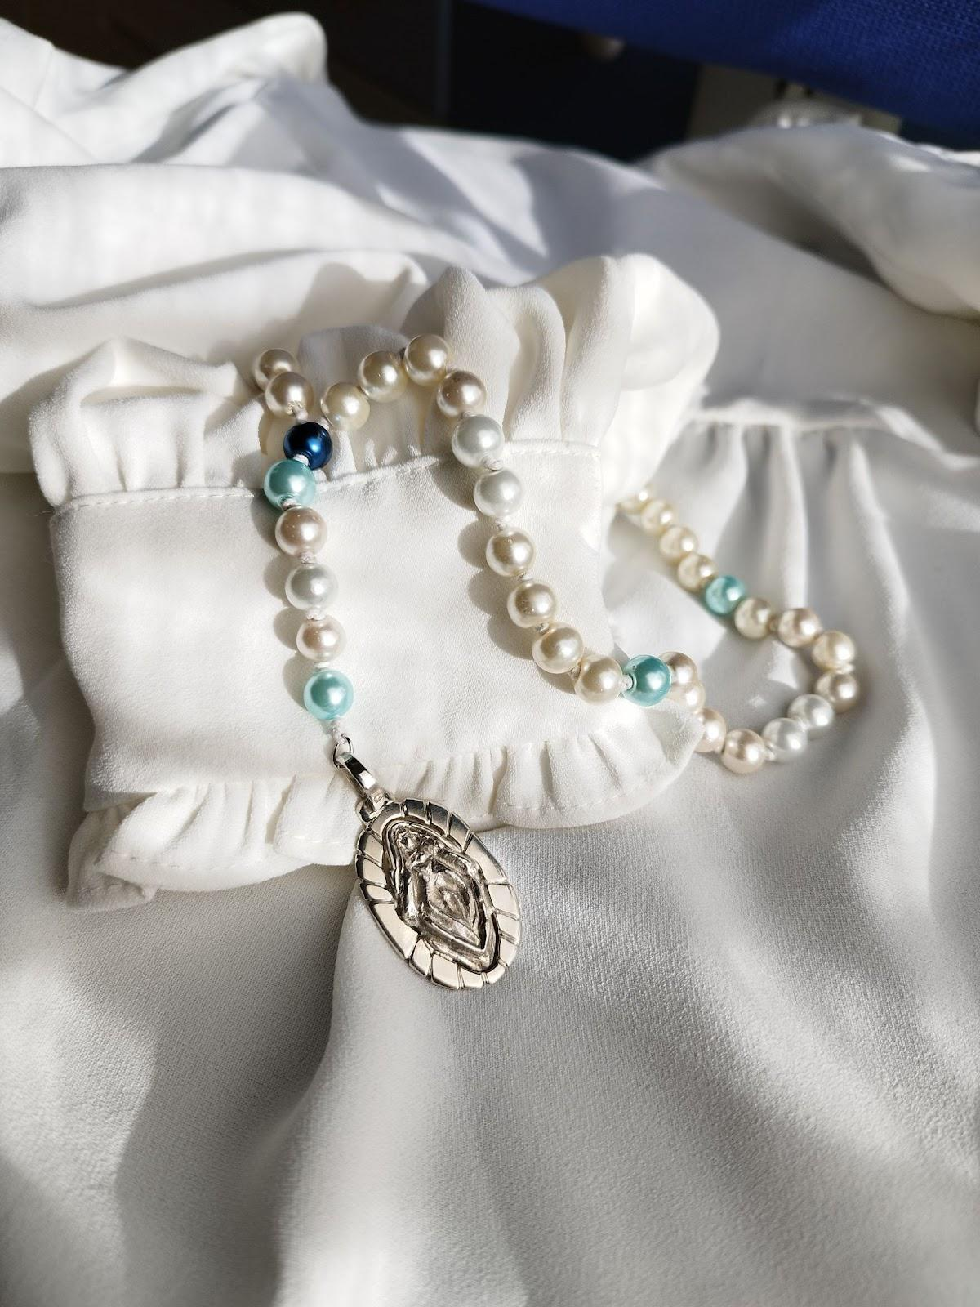

To adore and pleasure oneself with self-care rituals and joys that life offers, alone or in company. To honor and take care of yourself.

# 

# SAINT SELF

Saint Self is a striking self-portrait painted with acrylic on canvas and digitally enhanced. The central figure is a nude, vulnerable woman with a somber expression, her heart exposed. Though confident in her physical form, she struggles emotionally, always persevering but never feeling secure.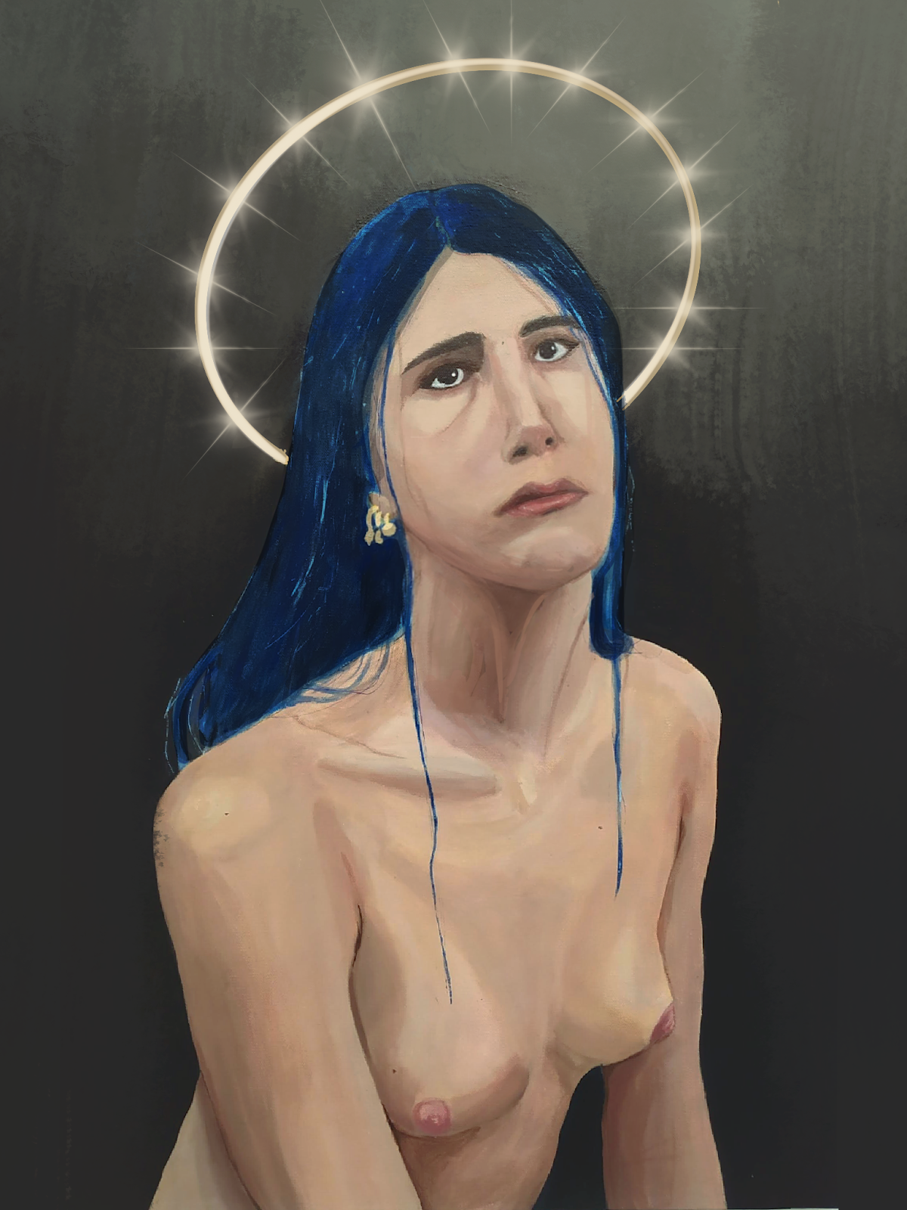

It has always been like this; the feelings do not go away. She is confident enough in her skin but never with her brain.

Why does she have to be that way…

# ORPHIC ROSETTE

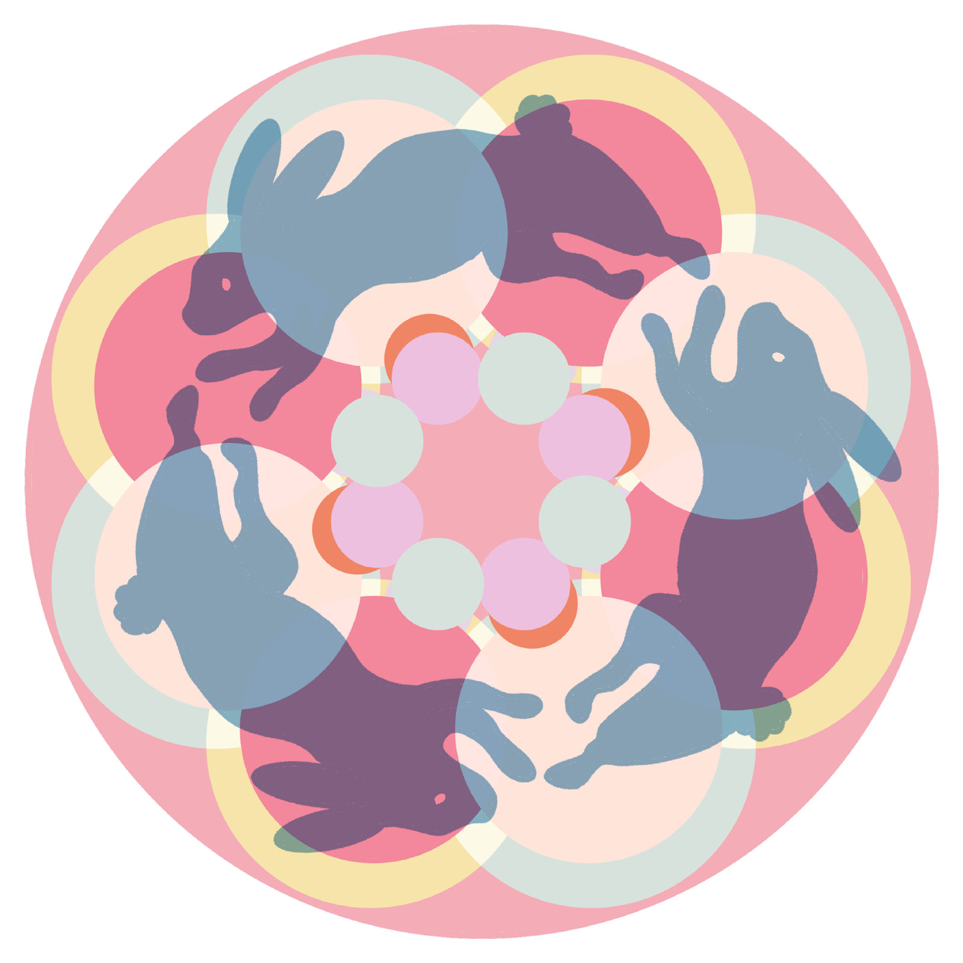

This artwork depicts bunnies moving gracefully in a counter-clockwise direction at a consistent speed. The larger circles rotate slowly in a clockwise direction, while the smaller ones spin faster and in different directions. This is the snapshot of the artwork before the animation starts.

The different color layers are set to blend in different digital blending modes, such as lightest color, multiply, and hard light. The color blocks appear transparent and blend with the colors on top or behind them, creating a slight sense of dimension. It is hard to see in a still image, but it is visible at the area of the top bunny head, where his blue color varies just slightly so as not to lose his shape, but still making it look like he is simultaneously on different planes of the artwork.

EMERGENCY HEART RING

This Sterling silver ring has been fabricated from scratch. The design includes a hinge on one side and a pressure mechanism inside to keep the top from opening.

Poison/pill/portrait rings have existed since the beginning of jewelry. I wondered what function I could give to a ring like this. I decided that it could store an emergency contraceptive pill. The wearer can use the pill or donate it to someone in need.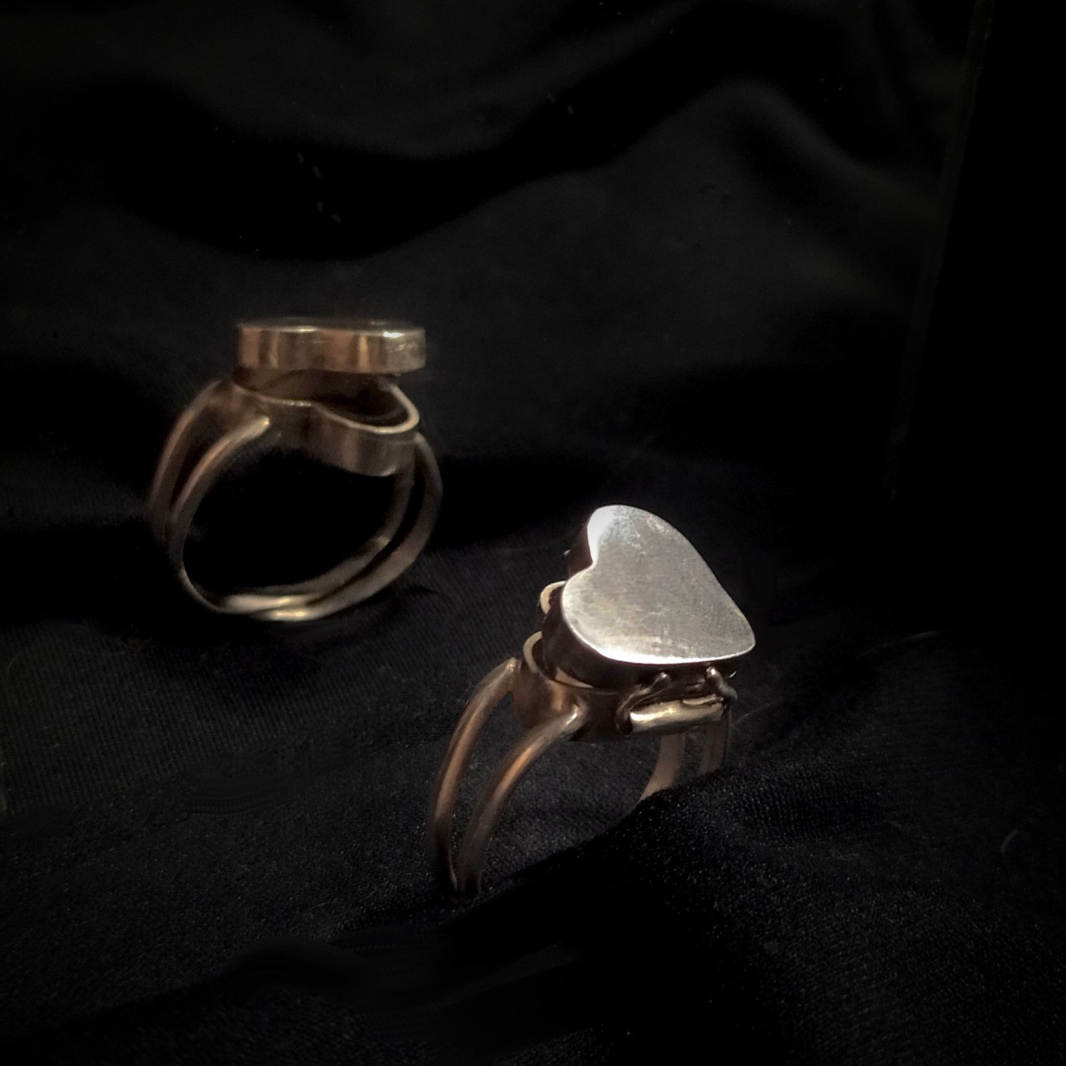

Taking a contraceptive pill is never a fun experience, but it does bring relief. This piece brings the pill closer to anyone needing it since it might not be available or heavily restricted to the person, depending on their situation. The concept is reminiscent of fire extinguishers or defibrillators, but it still conceals and hides the pill, so there is no public display or signaling that it exists. It just quietly waits until someone discreetly needs to use it.

# CONCLUSION

I still have no clue how to deal with Bunny or what to do with her. My (quite successful) attempts to appeal to the male gaze are rooted in a toxic coping mechanism. I do have to give myself credit for how creative and difficult the self-harm technique I chose was to find out. Which is a bad thing, but at least I am good at it.

I received many positive comments on the reception day, and while I did my best to keep the theme coherent, I wonder how much the public got to see. Much of the conceptual work was very hard to get through (especially because of the sexual nature of the main altar). Another thing I realized from the show is that I am very vulnerable to having people looking into my life. So, I show them a polished performance of vulnerability about a very intimate and personal topic, that is, sex, in the hopes that they get more flustered than me and look away. If I first present myself naked, with such confidence, people would not suspect that I am deeply embarrassed of myself (personality, psyche) and would not attempt to look further.

Through this project, I gained valuable experience in curating an exhibition that effectively communicates a narrative through the use of space and iconography. I developed a broad range of skills in working with various materials and techniques and coordinating all the necessary details to create and promote a professional gallery space. As a result, I am proud to have a collection of work that I can showcase in my portfolio upon graduation.

While I continue to focus on my personal growth and explore more positive avenues for healing, I will also keep a watchful eye on Bunny. Thank you for taking the time to read my confession.