BLaST and DPC Logos for BLaST Funded research for ALL POSTERS & FLYERS
AND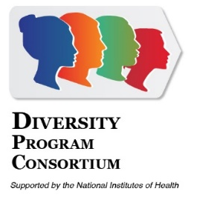or
CNSM Logo or UAF logo
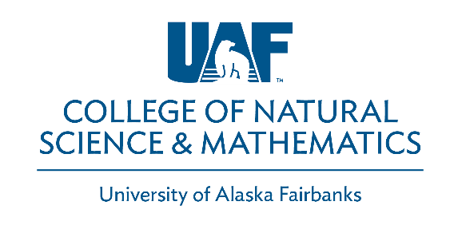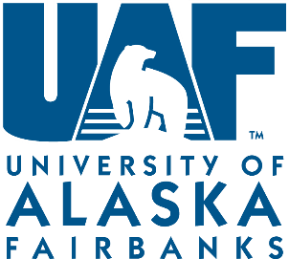
NIH AND UAF EEO STATEMENT COMBINED (NEED BOTH)
“BLaST is supported by the NIH Common Fund, through the Office of Strategic Coordination, Office of the NIH Director with the linked awards: TL4GM118992, RL5GM118990, & UL1GM118991. The content is solely the responsibility of the authors and does not necessarily represent the official views of the National Institutes of Health. UAF is an affirmative action / equal employment opportunity employer and educational institution: www.alaska.edu/nondiscrimination.”

REQUIRED FOR Scientific publications: the statement above is required, as well as making sure the publications are registered through Pub MED and Pub MED Central (two different publication databases). See website: https://publicaccess.nih.gov/

UAF EEO Statement WEBSITE: http://www.uaf.edu/oeo/civil-rights/aa-eo/
UAF BRANDING: http://www.uaf.edu/universityrelations/downloads/
For more information contact our office or Reporting & Outreach Coordinator at aktopkok@alaska.edu.

BLaST Email: blast.uaf@alaska.edu
BLaST Phone #: 907.474.5111
Address: PO Box 757770, Fairbanks, Alaska 99775-7770

