Cell and Molecular Biology.
BIOL360 (3) CRN 33141, 33260

Course Syllabus

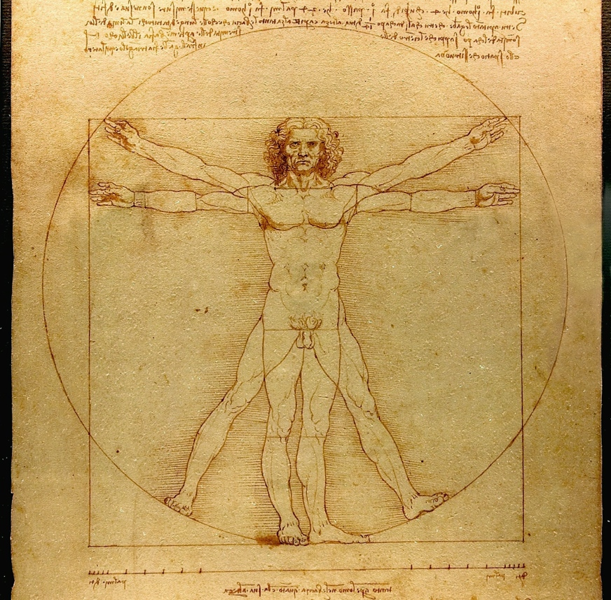
Leonardo da Vinci. The Vitruvian Man (drawing circa 1490)
Gallerie dell'Accademia, in Venice, Italy.

Andrej Podlutsky

University of Alaska Fairbanks
Spring Semester 2017
Classes: Tuesday & Thursday, Elvey Auditorium
11:30 – 1:00 pm

Course covers current knowledge of cellular and molecular biology: cell chemistry, transcription, translation, cell architecture, metabolism, signal transduction pathways, DNA repair and genome stability, cell division, and the cell cycle.

Version: 01/16/17
This syllabus is subject to change

Course syllabus*, content and format are modified from earlier offerings of Biology 360.

Syllabus: BIOL360 Cell and Molecular Biology
CRN 33141, CRN 33260
3 Credits
Prerequisites: BIOL F260; CHEM F105X; CHEM F106X or concurrent enrollment.

Lectures are: Tuesday & Thursday, 11:30 am – 1 pm, in Elvey Auditorium

Instructors:
Lecturer: Dr. Andrej Podlutsky (faculty IAB-CANHR)
e-mail: apodlutsky@alaska.edu
Office location/hrs: AHRB 2W04/Wed 10-12 or by appointment

Required Textbook: “Essential Cell Biology” [4th (preferable) or 3rd edition] By Alberts et al.
Garland Publishing.

TurningPoint® Clicker: the UAF Bookstore carries clickers that are compatible with the receiver in use
(ResponseCard RF). In order to register your new clicker: go to the course site in BlackBoard and click “Tools” and then “Turning Technologies Registration Tool”. Enter the 6-digit/letter Device ID, found just under the bar code. Note: if you already have a TurningPoint clicker linked to your student ID in BlackBoard, it should automatically be registered for the BIOL360 class. Make sure that it is the correct Device ID!

Course description: This course will provide an introduction to cell biology and will cover the following topics: cell chemistry, transcription, translation, cell architecture, metabolism, signal transduction pathways, cell division, and the cell cycle. Students will also learn current molecular biological techniques that are used to study these topics in the laboratory.

Course goals: Students will gain knowledge of cell structure and function, learn techniques commonly used in cell biology, sharpen their critical thinking skills, and gain insight to the cellular and molecular basis of disease.

Instructional methods: This course will be taught through a combination of lectures, group problem solving, brainstorming, and discussions.

Policies: Students are expected to attend lectures. Classes will start and end on time; you are expected to be on time. While there is no numerical penalty for missing class lectures, I will be taking note of absence. I have noticed a strong correlation between classes missed by a student and their grade. You are responsible for any material covered if absent from class regardless of the reason. Notes must be obtained from classmates. Exams will be based on material covered in both the lecture and your reading and account for a significant portion of your grade. Thus, missing classes will undoubtedly have a negative impact on your performance in this course.
I will be more than happy to help clarify material missed during any absence, but it must be during my office hours or another time outside of class that is convenient for both of us and you must be prepared (you must have read and thought about the material before meeting with me).
Electronic devices: please refrain from using any device in the class that might disrupt the lecture or your colleagues. This includes, but not limited to: cell phones, pagers, PDA, iPods (you get the idea).

Exams: Exams will be based on material covered in both the lecture and textbook. You are expected to take all exams at the scheduled time. Check the schedule carefully and plan your appointments and travel around the course schedule. In particular, make sure you schedule your travel plans for break after the final exam. I will not grant requests for early finals to accommodate early travel. Exams will contain multiple choice and short answer items.
Scheduled absences: For absences caused by conflict with a University-sanctioned activity (e.g., participation in a competition as a UAF athlete), you must notify me in advance of the exam. You will be expected to take the exam before your absence. Other types of scheduled absence are generally not accepted; you are expected to schedule around the exams.
Unscheduled (emergency) absences: If an emergency arises (ie: family death, medical emergency) the day of the exam that makes you unable to attend the exam, you must inform me before the start of the exam by e-mail or phone (leave a message if you can’t reach me). You must take a make-up exam within 48 hours of the scheduled exam. It is your responsibility to schedule the make-up. If not taken within 48 hours, the exam will be recorded as a zero. You should expect to provide documentation of the emergency. Make-up exam are not guaranteed; they are granted at the instructor’s discretion.

Blackboard: Slides used in lecture will be posted on Blackboard after the lecture. Please do not use these as a substitute for taking notes. The slides will contain mostly figures, illustrating many of the complex processes we will be discussing during class. I use minimal text on slides and strongly encourage you to take notes to enhance your understanding and learning of the material. Note taking is a skill that requires practice to master, and is essential for learning.
I also use Blackboard to post announcements, exam and homework, and any other interesting tidbits. Please check out the BB site on a regular basis. I also use the UAF email accounts to contact students. Please check your UAF account on regular basis. If you use an alternate account, please have your UAF mail forwarded to that account.

Email Etiquette: I will do my best to respond to your email inquiries within 24 hrs. Please be considerate in your letters and use proper English grammar. Think before you send and never write anything you would feel uncomfortable saying to me (or anyone else!) in person. Please sign your letter; addresses don’t always reveal the identity of the writer. I normally do not accept assignment via email.

Disabilities: I will work with the Office of Disabilities Service (203 WHIT, 474-7043) to provide accommodations in both the classroom and laboratory to provide equal access to all materials in this course to all students.

Grading: Your final grades will be based on the following:
- Exams (450 points): There will be four exams during the semester, one of which is the final exam. Each exam will count for 100 points (final exam 150 points total). The final exam will be 50% new material and 50% cumulative material. The questions at the end of each chapter are an excellent study guide. I strongly suggest that you test yourself with these questions after reading each chapter. Up to twenty points from each exam might be in the form of take-home questions in which you apply the knowledge you learn in class to solve problems. Exam policy – open notebook (with hand-written notes and illustrations) and your brain; final exam – just you and your powerful brain.

- Lecture and class participation points (clickers): active attendance of lecture is strongly recommended and encouraged. BIOL360 uses an active learning tool, clickers to pose questions to the class and evaluate student understanding. Clicker responses help instructor tell whether students are “getting it”, and are also used to assess class participation. Credits will be given simply for participating, and these points are an easy way to boost your grade (50 point, ~7.4% of total). However, giving your clicker to another student to use in your absence is considered academic fraud and will result in disciplinary action for both students. If you must miss class for university-sanctioned events, an illness (you or a dependent), or family emergency, please notify the instructor of the date and reason. Everyone will be granted 2 excused absences for personal reason. You will need to bring your clicker to every lecture, and it is your responsibility to ensure that clicker is operating properly.
- Quizzes (180 points): during the course, almost each Tuesday, we will have a quiz before the lecture. You will need to read whole chapter (sometimes, only part of the chapter) to do reasonably well during the quiz. You will be using your clicker (should register before the class) during the quiz.

BONUS: to earn extra points (maximum – 25 points) you will need to choose some exciting topic in “cell and molecular biology” and make a presentation for the whole class. Also, you will summarize your presentation in a two-page report (single spaced, including reference list). The topic should be interesting to everyone in the class; you could present your own research, but in a very illuminating way. Presentation length – 5-7 minutes, 6-7 slides. Bonus points will be added to the total sum before the final grade is calculated. If you decide to earn the bonus points, please send me an e-mail indicating the title of your presentation before February 9. I will make a schedule of all presenting students, and inform you about the date of your presentation (at least two weeks in advance).

In summary, your grade will be based on the following:

Component | Points | % of grade
Exams (3 at 100 pts each)  Final Exam (new + cumulative)  Lecture Participation Points (clicker points)  Quizzes (12 at 15 pts each) | 300  150  50  180 | 44%  22%  7%  26%
Σ Total | 680 | 100%

Grades: A= 90–100%, B= 80–90%, C= 70–80%, D= 60–70% and F< 60%.

Secrets to success: We will cover a large amount of material during this semester. Some of it may be familiar to you, but many topics will be new. There are few techniques you can use to help you to succeed in this course.
- Read the book before coming to lecture. This will allow you to familiarize yourself with the material before I cover it. Also, if you have questions about what you read, you can ask during the lecture. Please, please, never be afraid to ask a question. Undoubtedly there is someone else in the room wondering the same thing, and it will help everyone if I have an opportunity to explain something in a slightly different way, or clarify a point.
- Take notes during class. This is an excellent way to reinforce your learning of the material. Although I will post slides on Blackboard after the lecture, I will discuss the material in much more detail than is on the slide and you will be responsible for this material on the exam.
- Review your notes shortly after lecture, and ask me again if something is unclear, or fill in missing pieces with information from the text. Also (number 3.5), as I stated above, test yourself by answering the questions at the end of the text.
- Quiz yourself****. Use questions at the end of each chapter to test your understanding of the material. These questions are a GREAT way to study!!!

Most of all, do not procrastinate! There is no way you can do well on an exam in this course by waiting until the night before the exam to study.

Version: 1/16/2017
This syllabus is subject to change

* Acknowledgement:
This syllabus was developed with the help of Drs. Michael Harris, Kristin O’Brien, Diane O’Brien and Karsten Hueffer of UAF, their contribution is greatly appreciated. Any errors/mistakes, however, are sole responsibility of Andrej Podlutsky.

Date |  | Lecture | Exam | Book Chapter
Jan-17 | 1 | Introduction to Cell |  | Ch 1
Jan-19 | 2 | Introduction and Cell Chemistry |  | Ch 2
Jan-24 Q1 | 3 | Energy |  | Ch 3
Jan-26 | 4 | Proteins |  | Ch 4
Jan-31 Q2 | 5 | DNA and Chromosomes |  | Ch 5
Feb-02 | 6 | DNA Replication and Repair - I |  | Ch 6
Feb-07 Q3 | 7 | DNA Replication and Repair - II |  | Ch 6
Feb-09 |  |  | Exam 1
Feb-14 Q4 | 8 | Control of Gene Expression |  | Ch 8
Feb-16 | 9 | Genes and Genomes |  | Ch 9
Feb-21 Q5 | 10 | Recombinant DNA |  | Ch 10
Feb-23 | 11 | Membrane Structure |  | Ch 11
Feb-28 Q6 | 12 | Membrane Transport |  | Ch 12
Mar-02 | 13 | Metabolism |  | Ch 13
Mar-07 Q7 | 14 | Mitochondria |  | Ch 14
Mar-09 |  |  | Exam 2
Mar-14 |  | - - Spring break - -
Mar-16 |  | - - Spring break - -
Mar-21 Q8 | 15 | Protein Transport |  | Ch 15
Mar-23 | 16 | Cell Communication |  | Ch 16
Mar-28 Q9 | 17 | Cytoskeleton |  | Ch 17
Mar-30 | 18 | Cell Division |  | Ch 18
Apr-04 Q10 | 19 | Benefits of Sex |  | Ch 19
Apr-06 | 20 | Cell Cycle |  | Ch 18
Apr-11 Q11 | 21 | Cancer |  | Ch 20
Apr-13 | 22 | Aging |  | Lecture
Apr-18 Q12 | 23 | Stem Cells |  | Lecture
Apr-20 |  |  | Exam 3
Apr-25 | 24 | Make-up class/Discussion
Apr-27 | 25 | Make-up class/Discussion
May-04  Thursday |  | 10:15 am – 12:15 pm | Final Exam!

