G E O M O R P H O L O G Y
FALL 2012
THE STUDY OF EARTH’S SURFACE PROCESSES

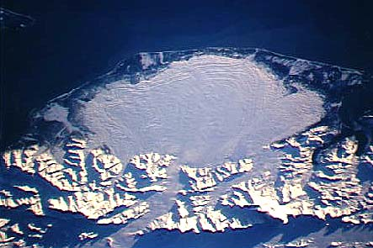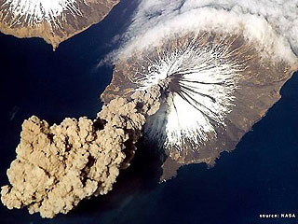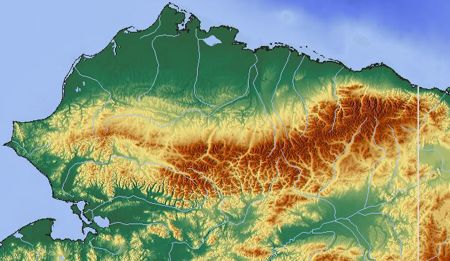

GEOLOGIC PROCESSES
ORIGIN OF LANDFORMS
NEOTECTONICS AND TECTONIC LANDFORMS
VOLCANIC PROCESSES AND LANDFORMS
WEATHERING AND EROSION
MASS WASTING PROCESSES and LANDFORMS
FLUVIAL PROCESSES and FLUVIAL LANDFORMS
EOLIAN PROCESSES and DESERT LANDFORMS
GLACIAL PROCESSES and GLACIAL LANDFORMS
PERIGLACIAL GEOMORPHOLOGY and LANDFORMS
THE ICE AGES AND CLIMATE CHANGE
NATURAL HAZARDS
LANDFORM EVOLUTION
GEOMORPHIC PROVINCES OF ALASKA AND THE WORLD

Professor: James Begét
Dept. Geology and Geophysics
364 Natural Science Building

Fall, 2012 GEOS 304 Geomorphology

°°°°°°°°°°°°°°°°°°°°°°°°°°°°°°°°°°°°°°°°°°°°°°°°°°°°°°°°°°°°°°°°°°°°°°°°°°°°°°°°
COURSE SYLLABUS
°°°°°°°°°°°°°°°°°°°°°°°°°°°°°°°°°°°°°°°°°°°°°°°°°°°°°°°°°°°°°°°°°°°°°°°°°°°°°°°°
Course Information

Course number: GEOS 304
Credits: 3
Place: 235 NCSI
Time: Tu/Th 9:45-11:15

Instructor: Dr. James Begét (Jim)
Office: Natural Science Building 364
Phone: 474-5301
Office Hrs: Monday 9-12..(also by appointment)
Email: jebeget@alaska.edu

Textbook: Bloom, A. L. 2004. Geomorphology (3rd edition)
Waveland Press, Illinois, USA
Course Introduction:
Geomorphology is the scientific study of the active processes that create landforms on the surface of the earth. Geomorphologists study all of the earth’s landforms, including mountains, lakes, lava flows, fault scarps, beaches, terraces, moraines, etc., to determine their age, origin, distribution, and significance, and to better understand the processes that created them.
The origin of the various landscapes and features seen on the surface of the earth is of popular as well as scientific interest. The earliest known writings on natural science, in the 4th century BC by Aristotle and Herodotus, include observations of landforms and processes at the earth’s surface. Leonardo daVinci and others during the Renaissance tried to explain the origins of landforms, and Darwin, Humboldt, J. W. Powell, and others described new landforms from around the world as part of the scientific exploration of the earth during the 16-20th centuries. During the 21st century new landforms are being discovered and described on Mars and other planets and moons in our solar system by NASA and ESA scientists through the now operational Curiousity Rover and other space systems.
Modern geomorphology focuses on the types and rates of processes which create and modify landforms. These studies have critical “real-world” applications as landforms and surficial sedimentary deposits record recent earth events. Geomorphology plays a key role in evaluating climate change, environmental shifts and natural hazards.
This course will survey the landforms of the world, describe the processes that operate in particular climates or tectonic settings to produce distinctive landforms, and discuss how geomorphology can be used to evaluate climate change and natural hazards in Alaska and other areas.

Course Goals:
1) Recognition of the diversity and natural history of landscapes and landforms in Alaska and throughout the world.
(2) Introduction to modern methods of study of landforms, Quaternary sediments, and physical processes which modify the earth's surface.
(3) Applications of geomorphology and surficial geology to natural hazards evaluations, engineering geology, land-use planning, economic geology, archeology, paleoecology, paleoclimatology, and other scientific problems.

Course Format:
Material will be presented in a lecture format. Each class will begin with an hour-long lecture, followed by slides or powerpoint images showing examples of landforms and illustrating the processes involved in their formation. Class discussion and participation are encouraged, and questions can be asked at any point in the lectures. Readings from the text supplement the lecture material and are required. Several "mini-labs" during the term will introduce students to geomorphologic data. A few films will be shown. A guest lecture or two is possible.

Field Trips
Geomorphology is a field science. There will be a required one-
day field trip in late September, and we will use one class period to look at geomorphic features around the UAF campus. Neither trip is mandatory, but both are highly recommended. Both fieldtrips will also count as a “mini-lab.” If you are unable to attend the Saturday fieldtrip, a “take-home” project will be available to replace it.

Assigned Readings:
Sections of the textbook are assigned each week in the syllabus. The readings are keyed to class lectures. You should try to read the text before the lecture. Exam questions will come from both the readings and lecture.

Class Exercise (mini-labs):
Two additional short exercises will be completed during the term. These "mini-labs" are designed to demonstrate fundamental concepts. You will need a pocket calculator for some exercises.

Examinations:
There will be three examinations, each covering one-third of the term. Each will account for 30% of the grade. Exams will cover lecture, readings, and in-class exercises. Exams will not be cumulative. No make-up exams will be given. If you know ahead of time that you must miss an exam, or if you miss an exam for an emergency (i.e. some natural hazard, of course) or other reason, please let me know as soon as possible and so we can arrange a replacement exam by appointment.

Grading:
Each of the three exams will count 30% of the final grade, so 90% of a student’s grade is based on the objective scores on the exams. The remaining 10% is based on completion of 3 of the 4 in-class mini-labs, including the class fieldtrips.

LECTURE OUTLINE AND ASSIGNED READING

PART ONE: CONSTRUCTIONAL PROCESSES

Date ___Lecture Topics _____________Assigned Reading

AUG. 30 Organization meeting, syllabus p. 3-12B

SEPT. 4 Syllabus p. 19-34B
Scope of Geomorphology
History of Geomorphology Constructional processes

6 Neotectonic landforms, processes

11 Neotectonics continued p. 35-48B, 67-87B

13 Tectonic geomorphology
Constructional landforms,
Faulting and folding

15 (Saturday) Geomorphology Field Trip—Fairbanks

18 Paleoseismology, hazards

20 Neotectonics/ Alaskan seismic hazards

25 intro volcanic geomorphology p. 92-113B

27 Volcanic landforms, processes (lava)

OCT. 2 Volcanic landforms, Volcanic processes

4 Mt. St. Helens./AK. volcanoes

9 First Examination

PART TWO: WEATHERING/SURFICIAL PROCESSES

11 Chemical weathering p. 117-146B
16 chemical weathering

18 Physical weathering p. 204-209S
Physical weathering (continued)

23 soils, karst p. 147-168B

25 mass wasting p. 169-188B
landslides, rockfalls

30 Hillslope morphology p. 188-195B
progressive evolution

NOV 1 Fluvial processes p. 13-16B, 198-227B

6 Fluvial landforms p. 231-274

8 Paleohydrology, flood hazards

13 Second mid-term examination

PART THREE: SURFICIAL PROCESSES---SPECIFIC CONTROLLING FACTORS

15 Shoreline processes p. 417-442B

20 Shoreline landforms p. 445-459B

22 THANKSGIVING HOLIDAY

27 Eolian-arid processes p. 277-305B
Eolian landforms

29 Loess in Fairbanks/global climate change

DEC 4 Periglacial processes p. 309-322B
Periglacial landforms

6 Geomorphology of glaciers
ice sheetsvalley glaciers p. 353-372B
Glacial Geology p. 373-390B
Glacier landforms

Final Examination (UAF finals schedule)

MERRY CHRISTMAS, HAPPY WINTER HOLIDAY, AND A HAPPY NEW YEAR!!!

