GEOS 670: Selected Topics In Volcanology

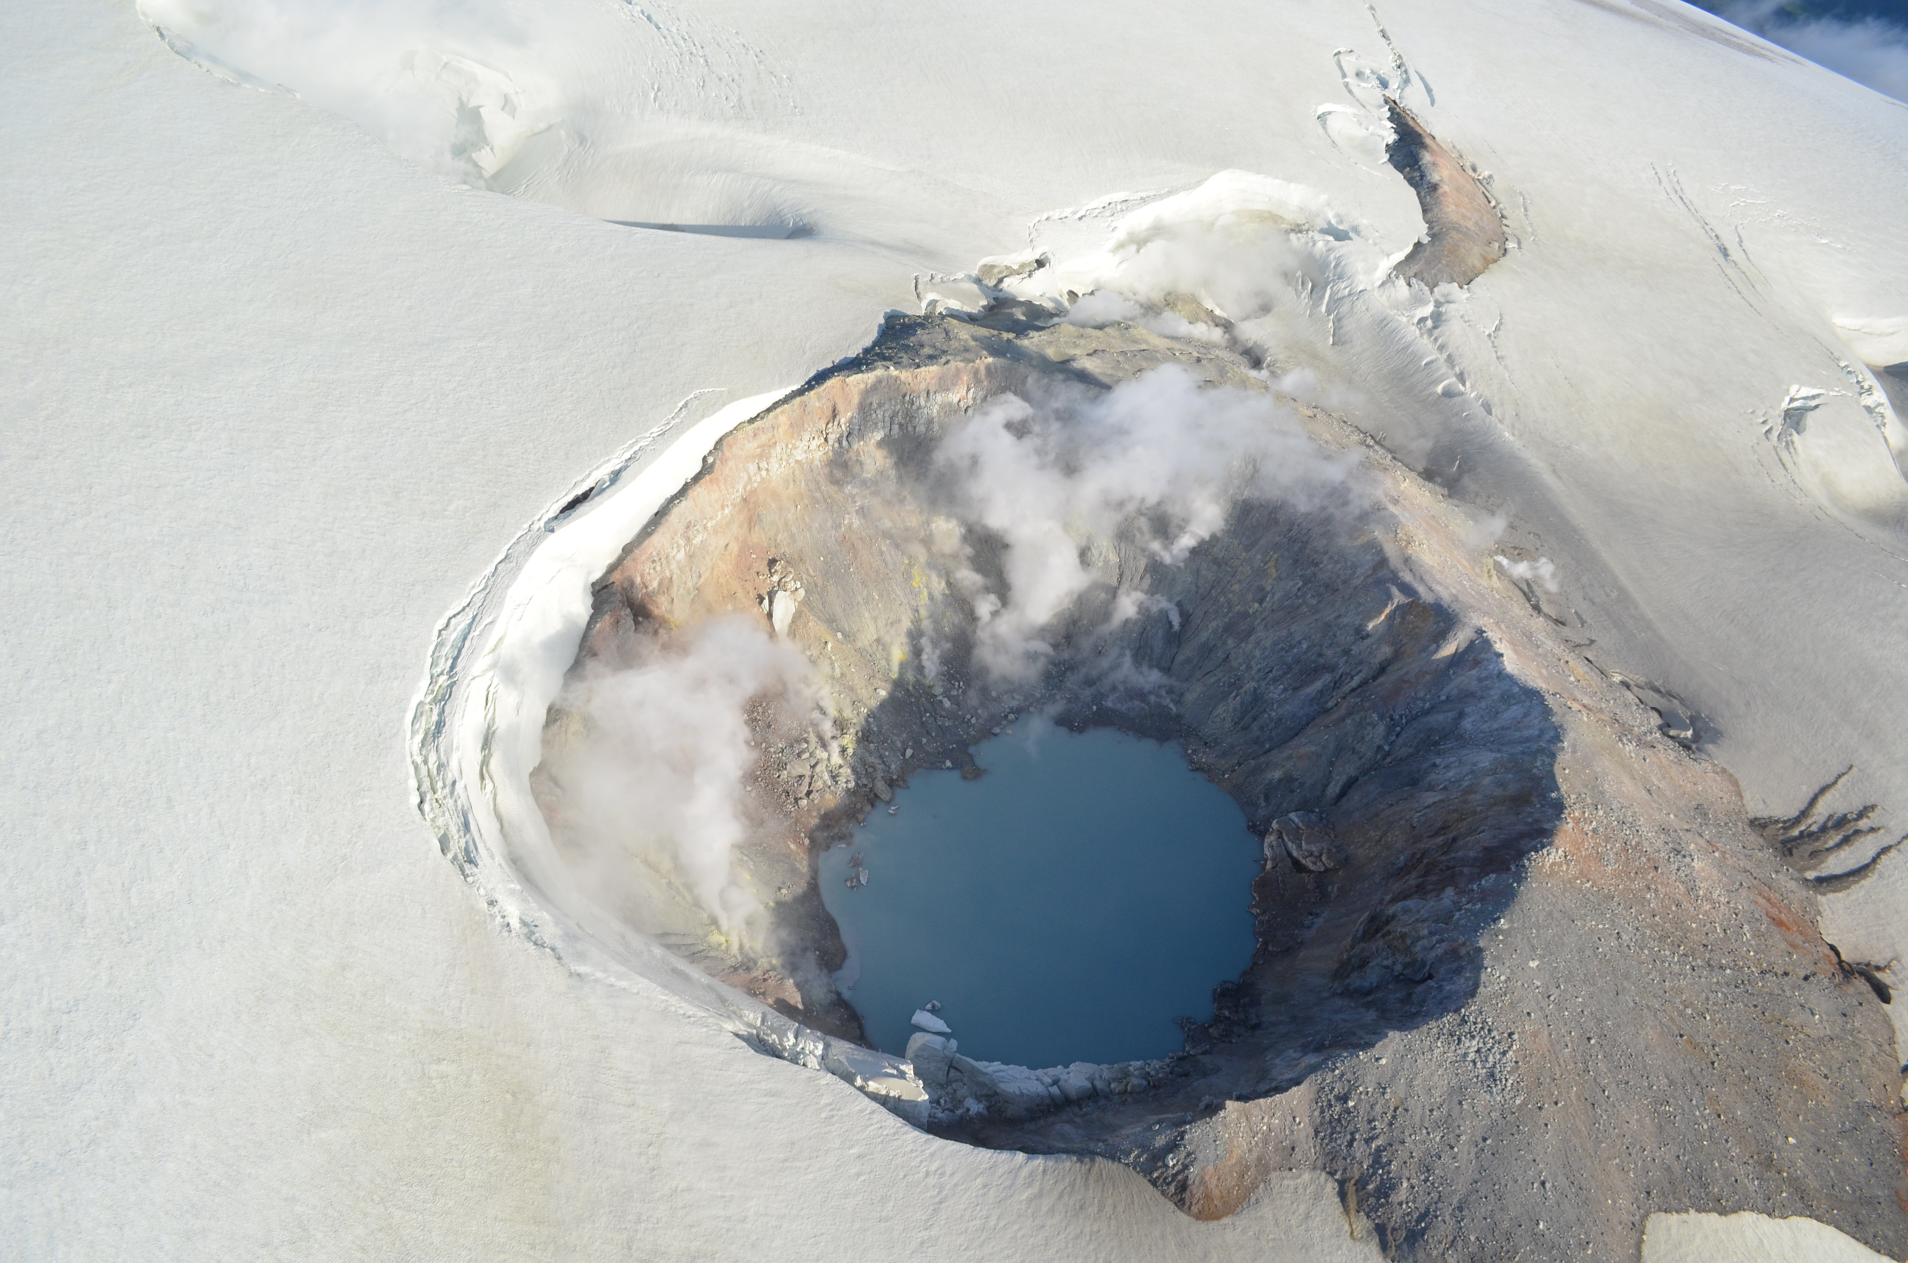
Prof. Jessica F. Larsen
Rm. 344 Reichardt Bldg.
Dept. of Geology and Geophysics
Univ. of AK, Fairbanks
474-7992
faust@gi.alaska.edu

Seminar hours:
Thurs. 1:00 to 3:00 PM
Course schedule:
Aug. 30 to Nov. 1.
NO CLASS OCT. 11

Introduction: GEOS 670 is a seminar that goes beyond simply reading current literature in volcanology (and related) topics. We will use active, discussion-based learning in small groups to gain a more in-depth understanding of select articles by drawing out key points, looking for important limitations and issues inherent in every paper, and presenting summaries of the major points discussed. A major goal is to use this time to enrich your thesis research by uncovering new ideas or past research that is relevant, and gain a more complete understanding of your topic.

Instructional Methods: In order to keep the discussion flowing, and avoid sleep-inducing lecturing, we will use the following methodologies:
Students assign 1-2 papers to the class each week and formulate weekly key discussion questions.
Students and instructor prepare for each class session by reading the assigned papers.
The first hour of each session will be spent in small groups discussing the papers, focusing on the key questions, and documenting the discussion. The second hour will involve student-led summaries of the key discussion points to the whole class.
The last class on Oct. 25 will be devoted to short (20 minutes max) presentations by each student summarizing their paper/topic and the key findings of the group discussion.

Goals and Learning Outcomes: Students enrolled in GEOS 670 will gain or hone their skills in the following:
You will gain a more thorough understanding of the topic of your choice.
Engaging in active group discussion and presentation will provide practice dissecting scientific articles, drawing out key important points, and applying the literature review process to your own thesis research.
Formulate and deliver an effective presentation on your topic of choice. Practice delivering effective presentations is always useful.

Grading and Requirements:
Although this course is designated as “letter grade”, it is discussion-based, and thus more appropriate for “pass/fail” type grading. I will not split hairs to grade people along a traditional bell-curve. Rough guidelines are below:
A - Attend class regularly, participate in “active” discussion groups, prepare and deliver a high quality powerpoint presentation on your topic.
C – Miss several classes with no excuse, participation in discussion groups is somewhat lacking, prepare a “so-so”, but adequate presentation.
F – Fail to attend class regularly, participation in discussion groups is severely lacking, presentation is inadequate.

Class Schedule and Reading Assignments: The schedule will be determined by student choice. During the first course session on Aug. 30, we will set the schedule, with student presentations on Nov. 1

Accessibility: The Office of Disability Services implements the Americans with Disabilities Act (ADA) and ensures that UAF students have equal access to the campus and course materials. I will work with the Office of Disability Services (474-7043) to provide reasonable accommodation to students with disabilities. Please let me know at the beginning of the course if accommodations should be provided.

Student Conduct: The Student Code of Conduct is listed on page 49 of the UAF catalog. The code outlines your rights and responsibilities, as well as conduct that is prohibited by the University. Please be familiar with the contents of this document.

