INVENTING THE SUIT AND SAVING THE WORLD: ONE HUMAN’S STORY OF UNPARALLELED GENIUS, INTERMINABLE COURAGE, AND GENERAL AWESOMENESS

by
Anthony Stark
B.S. University of Pirates, 2020
M.S. College of Technology, 2019

A Dissertation submitted in Partial Fulfillment of the Requirements
for the Degree of

Doctor of Philosophy
in
Engineering

University of Alaska Fairbanks
August 2023

APPROVED:
Bruce Banner, Committee Chair
Thor Odinson, Committee Member
Natasha Romonoff, Committee Member
Jane Van Dyne, Committee Member
Clinton F. Barton, Chair
Department of Mechanical Engineering
Nick Fury, Dean
College of Business and Security Management
Richard Collins, Director
Graduate School

Copyright

© Copyright by Anthony Stark
All Rights Reserved

Dedication
To Wanda Maximoff:

Write as a block (or single paragraph) with no indentation. The dedication is optional. A dedication is an expression of friendly connection, gratitude, or thanks by the author towards another person or person(s). It may also be used to highlight a connection to a community or cause. Adapted from Wikipedia. The dedication has its own place on the dedication page and is part of the front matter.

Abstract
Abstract to be less than 300 words. The abstract is required. Write as a single block without indentation. An abstract is a concise summary of your dissertation. It should summarize your dissertation, its results, and their broader relevance. It allows readers determine the relevance of your dissertation for their own research and serves as an invitation to them to read it. It also communicates your key findings to those who don’t have the time to read your entire dissertation.

Plain Word Summary
Plain word summary to be less than 300 words. The plain word summary is optional. Write as a single block without indentation. A plain word summary should convey the same information as the abstract but in a different language and tone. It should summarize your dissertation, its results, and their broader relevance without using jargon so that it is understandable by readers from outside of your discipline, as well as journalists and educators. The audiences include, but are not limited to, practitioners, policy makers, the public, and/or professionals in nearby disciplines.

Acknowledgements
Write as a paragraph, or paragraphs, with indentation. The acknowledgements section is optional. The acknowledgments section is where you recognize and thank everyone (mentor/advisor committee, friends, family, colleagues, communities, organizations, agencies) who helped you with your dissertation and contributed to your success. It’s a way to show your appreciation and recognition of them in a public and permanent forum. You can also include a Land Acknowledgement in the acknowledgements. It is also the section where you can formally report any agencies and organizations that provided financial or other material support for your work (e.g., I acknowledge the support of the UAF graduate school for …., I thank Foundation X for ….). I acknowledge the support of the graduate school for a travel grant in Fall 2022. I acknowledge the support of the National Science Foundation under grant 2012345.

Table of Contents

Copyright iii
Dedication iv
Abstract v
Plain Word Summary vi
Acknowledgements vii
Table of Contents viii
List of Figures ix
List of Tables x
Chapter 1: Introduction 1
Chapter 2: Methods 2
2.1 Study System 2
2.2 Mathematical Model 2
2.3 Statistical Model 2
Chapter 3: Results 4
3.1 Steady State Solution 4
3.2 Non-territorial Individual Analysis 4
Chapter 4: Discussion 6
References 7
Appendix A: Supplemental Material 8
Appendix B: More Supplemental Material 9

List of Figures
Figure 1.1: A capybara wearing a suit. Probably has an important meeting to get to. 1
Figure A.1: Frog looking real dapper. 8

List of Tables
Table 2.1: Model components and parameters making up advection diffusion model as well as biological interpretation in model’s system. 3
Table 3.1: They all seem to be negative. Maybe that’s significant? Maybe it’s not. Why are a bunch of them 0.1? 4

Introduction
Lorem ipsum dolor sit amet, consectetuer adipiscing elit. Ut purus elit, vestibulum ut, placerat ac, adipiscing vitae, felis. Curabitur dictum gravida mauris. Nam arcu libero, nonummy eget, consectetuer id, vulputate a, magna. Donec vehicula augue eu neque. Pel- lentesque habitant morbi tristique senectus et netus et malesuada fames ac turpis egestas. Mauris ut leo. Cras viverra metus rhoncus sem. Nulla et lectus vestibulum urna fringilla ultrices. Phasellus eu tellus sit amet tortor gravida placerat. Integer sapien est, iaculis in, pretium quis, viverra ac, nunc. Praesent eget sem vel leo ultrices bibendum. Aenean faucibus. Morbi dolor nulla, malesuada eu, pulvinar at, mollis ac, nulla. Curabitur auctor semper nulla. Donec varius orci eget risus. Duis nibh mi, congue eu, accumsan eleifend, sagittis quis, diam. Duis eget orci sit amet orci dignissim rutrum.

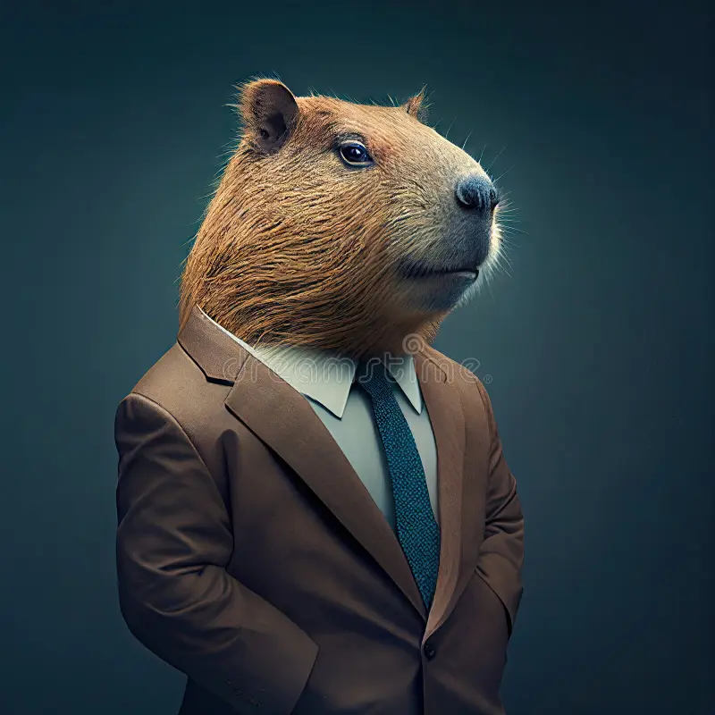
Figure 1.1: A capybara wearing a suit. Probably has an important meeting to get to.

Methods

2.1 Study System
Nam dui ligula, fringilla a, euismod sodales, sollicitudin vel, wisi. Morbi auctor lorem non justo. Nam lacus libero, pretium at, lobortis vitae, ultricies et, tellus. Donec aliquet, tortor sed accumsan bibendum, erat ligula aliquet magna, vitae ornare odio metus a mi. Morbi ac orci et nisl hendrerit mollis. Suspendisse ut massa. Cras nec ante. Pellentesque a nulla. Cum sociis natoque penatibus et magnis dis parturient montes, nascetur ridiculus mus. Aliquam tincidunt urna. Nulla ullamcorper vestibulum turpis. Pellentesque cursus luctus mauris.

2.2 Mathematical Model
Nulla malesuada porttitor diam. Donec felis erat, congue non, volutpat at, tincidunt tristique, libero. Vivamus viverra fermentum felis. Donec nonummy pellentesque ante. Phasellus adipiscing semper elit. Proin fermentum massa ac quam. Sed diam turpis, mo- lestie vitae, placerat a, molestie nec, leo. Maecenas lacinia. Nam ipsum ligula, eleifend at, accumsan nec, suscipit a, ipsum. Morbi blandit ligula feugiat magna. Nunc eleifend conse- quat lorem. Sed lacinia nulla vitae enim. Pellentesque tincidunt purus vel magna. Integer non enim. Praesent euismodnunc eupurus. Donec bibendumquam in tellus. Nullamcursus pulvinar lectus. Donec et mi. Nam vulputate metus eu enim. Vestibulum pellentesque felis eu massa.

$$\begin{aligned}\frac{∂u_{i}}{∂t}=\underset{\text{Random Motion}}{\underbrace{D∇^{2}u_{i}}}-\underset{\text{Directed Motion}}{\underbrace{2∇\left[A_{i}∇u_{i}\right]}}\#(2.1)\end{aligned}$$

2.3 Statistical Model
Quisque ullamcorper placerat ipsum. Cras nibh. Morbi vel justo vitae lacus tincidunt ultrices. Lorem ipsum dolor sit amet, consectetuer adipiscing elit. In hac habitasse platea dictumst. Integer tempus convallis augue. Etiam facilisis. Nunc elementum fermentumwisi. Aenean placerat. Ut imperdiet, enim sed gravida sollicitudin, felis odio placerat quam, acpulvinar elit purus eget enim. Nunc vitae tortor. Proin tempus nibh sit amet nisl. Vivamus quis tortor vitae risus porta vehicula.
$$\begin{aligned}f\left(x | y, θ_{0}\right)= \frac{ϕ\left(x | y,θ_{0}\right) ω\left(x,β\right)}{\int_{Ω}{ϕ\left(x^{'} | y,{θ^{'}}_{0}\right) ω\left(x^{'},β\right)}}\#\left(2.2\right)\end{aligned}$$

Parameter | Interpretation | Dimensions
x | spatial location | [1x2]
u_{i}(x,t) | individual territory | [1x1] (i=5)
V_{hr} | vector field defining available space | [1x1]
B(x) | perceptive range of individual | [1x12]
s_{j}(x,t|B(x)) | Spatially averaged effect in perceptive range | [1x1] (j=4)
B^{C}_{i,j} | effect of conspecific (from iSSA) | [5x5]
Table 2.1: Model components and parameters making up advection diffusion model as well as biological interpretation in model’s system.

Results
Lorem ipsum dolor sit amet, consectetuer adipiscing elit. Ut purus elit, vestibulum ut, placerat ac, adipiscing vitae, felis. Curabitur dictum gravida mauris. Nam arcu libero, nonummy eget, consectetuer id, vulputate a, magna. Donec vehicula augue eu neque. Pel- lentesque habitant morbi tristique senectus et netus et malesuada fames ac turpis egestas. Mauris ut leo. Cras viverra metus rhoncus sem. Nulla et lectus vestibulum urna fringilla ultrices. Phasellus eu tellus sit amet tortor gravida placerat. Integer sapien est, iaculis in, pretium quis, viverra ac, nunc. Praesent eget sem vel leo ultrices bibendum. Aenean faucibus. Morbi dolor nulla, malesuada eu, pulvinar at, mollis ac, nulla. Curabitur auctor semper nulla. Donec varius orci eget risus. Duis nibh mi, congue eu, accumsan eleifend, sagittis quis, diam. Duis eget orci sit amet orci dignissim rutrum.

3.1 Steady State Solution
Nam dui ligula, fringilla a, euismod sodales, sollicitudin vel, wisi. Morbi auctor lorem non justo. Nam lacus libero, pretium at, lobortis vitae, ultricies et, tellus. Donec aliquet, tortor sed accumsan bibendum, erat ligula aliquet magna, vitae ornare odio metus a mi. Morbi ac orci et nisl hendrerit mollis. Suspendisse ut massa. Cras nec ante. Pellentesque a nulla. Cum sociis natoque penatibus et magnis dis parturient montes, nascetur ridiculus mus. Aliquam tincidunt urna. Nulla ullamcorper vestibulum turpis. Pellentesque cursus luctus mauris.
 | TET052 | TET030 | TET072 | TET062 | TET074
TET052 | - | -0.3 | -0.1 | -0.1 | -0.14
TET030 | -0.26 | - | -0.1 | -0.2 | -0.2
TET072 | -0.1 | -0.1 | - | -0.13 | -0.1
TET062 | -0.1 | -0.31 | -0.16 | - | -0.1
TET074 | -0.13 | -0.21 | -0.1 | -0.1 | -
Table 3.1: They all seem to be negative. Maybe that’s significant? Maybe it’s not. Why are a bunch of them 0.1?

3.2 Non-territorial Individual Analysis
Nulla malesuada porttitor diam. Donec felis erat, congue non, volutpat at, tincidunt tristique, libero. Vivamus viverra fermentum felis. Donec nonummy pellentesque ante. Phasellus adipiscing semper elit. Proin fermentum massa ac quam. Sed diam turpis, mo- lestie vitae, placerat a, molestie nec, leo. Maecenas lacinia. Nam ipsum ligula, eleifend at, accumsan nec, suscipit a, ipsum. Morbi blandit ligula feugiat magna. Nunc eleifend conse- quat lorem. Sed lacinia nulla vitae enim. Pellentesque tincidunt purus vel magna. Integer non enim. Praesent euismodnunc eupurus. Donec bibendumquam in tellus. Nullamcursus pulvinar lectus. Donec et mi. Nam vulputate metus eu enim. Vestibulum pellentesque felis eu massa.

Chapter 4: Discussion
Fusce mauris. Vestibulum luctus nibh at lectus. Sed bibendum, nulla a faucibus semper, leo velit ultricies tellus, ac venenatis arcu wisi vel nisl. Vestibulum diam. Aliquam pellen- tesque, augue quis sagittis posuere, turpis lacus congue quam, in hendrerit risus eros eget felis. Maecenas eget erat in sapien mattis porttitor. Vestibulum porttitor. Nulla facilisi. Sed a turpis eu lacus commodo facilisis. Morbi fringilla, wisi in dignissim interdum, justo lectus sagittis dui, et vehicula libero dui cursus dui. Mauris tempor ligula sed lacus. Duis cursus enim ut augue. Cras ac magna. Cras nulla. Nulla egestas. Curabitur a leo. Quisque egestas wisi eget nunc. Nam feugiat lacus vel est. Curabitur consectetuer.

References
Einstein, A., Darwin, C. & Linnaeus, C. (1425) The hungry hungry moose. Journal of Hungry Animals. 3, 2150–8925.
Styles, H., Horan, N., Payne, L., Tomlinson, L. &Malik, Z. (1985) How many directions are there: Only the one. Scandinavian Journal of Music. 12, 97–15.

Supplemental Material
Nulla malesuada porttitor diam. Donec felis erat, congue non, volutpat at, tincidunt tristique, libero. Vivamus viverra fermentum felis. Donec nonummy pellentesque ante. Phasellus adipiscing semper elit. Proin fermentum massa ac quam. Sed diam turpis, mo- lestie vitae, placerat a, molestie nec, leo. Maecenas lacinia. Nam ipsum ligula, eleifend at, accumsan nec, suscipit a, ipsum. Morbi blandit ligula feugiat magna. Nunc eleifend conse- quat lorem. Sed lacinia nulla vitae enim. Pellentesque tincidunt purus vel magna. Integer non enim. Praesent euismodnunc eupurus. Donec bibendumquam in tellus. Nullamcursus pulvinar lectus. Donec et mi. Nam vulputate metus eu enim. Vestibulum pellentesque felis eu massa.

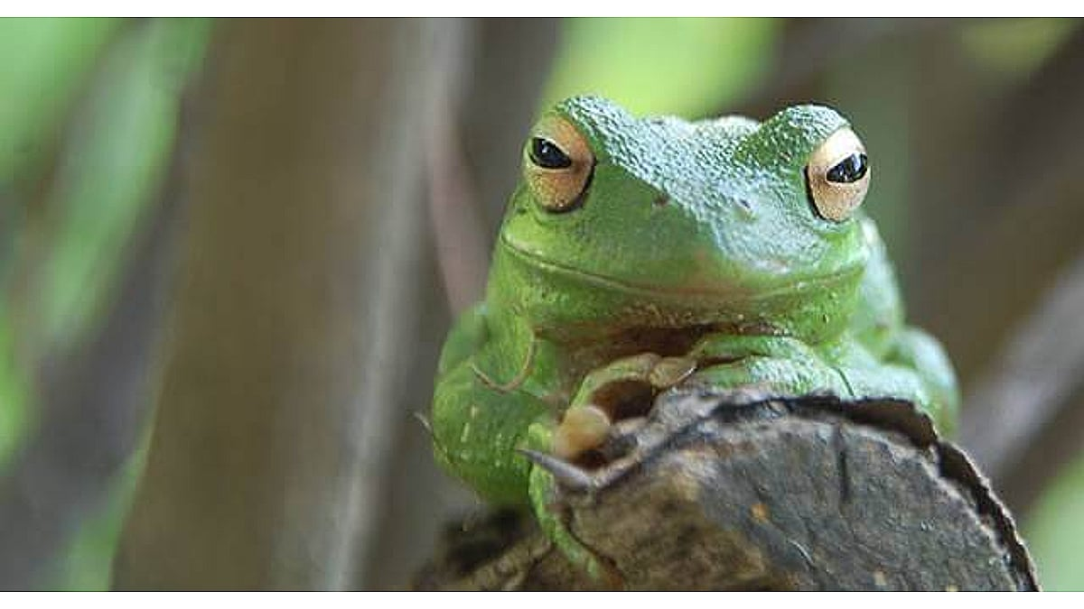
Figure A.1: Frog looking real dapper.

More Supplemental Material
Sed commodo posuere pede. Mauris ut est. Ut quis purus. Sed ac odio. Sed vehicula hendrerit sem. Duis non odio. Morbi ut dui. Sed accumsan risus eget odio. In hac habitasse platea dictumst. Pellentesque non elit. Fusce sedjusto eu urna porta tincidunt. Mauris felis odio, sollicitudin sed, volutpat a, ornare ac, erat. Morbi quis dolor. Donec pellentesque, erat ac sagittis semper, nunc dui lobortis purus, quis congue purus metus ultricies tellus. Proin et quam. Class aptent taciti sociosqu ad litora torquent per conubia nostra, per inceptos hymenaeos. Praesent sapien turpis, fermentum vel, eleifend faucibus, vehicula eu, lacus.

