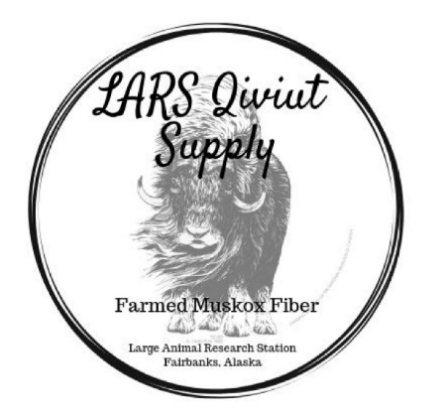
Qiviut Fichu
a qiviut lace shawlette
Https://www.uaf.edu/lars/

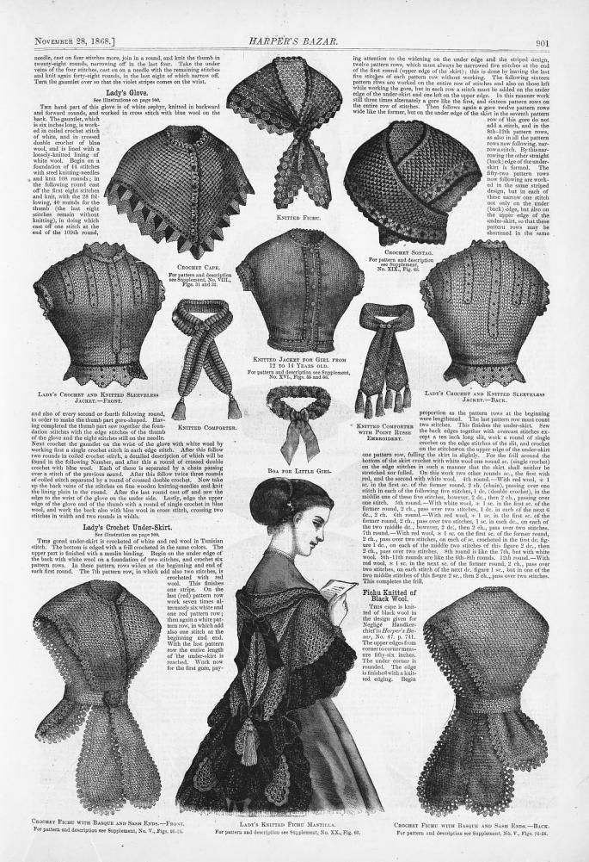
Fichu (fi-SHōō) is a French term for a small triangular shawl worn around a woman’s shoulder and neck during the Victorian period. In Victorian Lace Today, Jane Sowerby describes fichus as being worn “over dresses to cover the front and back of the bodice for warmth, modesty, or decoration”.
While the common shape was triangular, the term fichu also included collars and rounded capes and shawls with ends crossed at the waist – either fastened or tied.

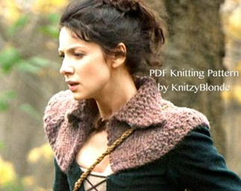
FUN FACT: the character Claire in the series Outlander wore a number of different fichu, ranging from delicate lace fabric to thick, cozy, capelets (pictured) and shawls tied around the waist. It’s given rise to a number of knitting and crochet patterns. (google outlander knitted patterns).

QIVIUT FICHU
The fichu is the perfect accessory for qiviut – a small shawlette that can be worn as a neck scarf or over the shoulders like a shawl with the ends fastened in front. In its simplest form it’s a beginner pattern, while different edgings increase the complexity, knitting challenge and appearance.
This simple triangle is knit from the top down with paired increases down the center line and extra increases at either end to extend the side length, creating a crescent-like shape. It is designed to use a single ounce of lace weight qiviut from LARS Qiviut Supply.
The basic pattern is suitable for beginners with a working knowledge of knit (K), purl (P) and yarn over (yo) stitches.
The pattern comes with instructions for a picot cast off edging (with or without beads).
Materials:
1 ounce lace weight qiviut from LARS Qiviut Supply. Contrast color for the edging is optional.
Knitting needles: size US 4 (3.5 mm) – US 6 (4 mm). The larger size will create a more open, lacy effect in the stockinette portion. Straight needles can be used but circular knitting needles with a 36” – 40” cable will make it easier to hold the large number of stitches.
Stitch markers
Gauge: 20 st (3.5mm) or 18 st (4mm) over 4” (stockinette stitch, blocked)
Optional: beads and a crochet hook that will go through the beads. (the beads used here were seed beads 6/0 with US 10/1.15 mm crochet hook or smaller). Keep in mind that qiviut is very light and heavy beads (glass or ceramic) will stretch the knitting.

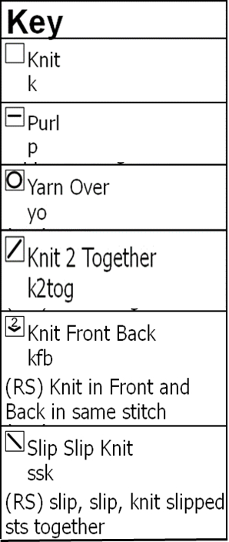
KEY TO ABBREVIATIONS AND CHART SYMBOLS

St - stitch
sm – slip marker

Cast on 5 st. Place a marker between the second and third stitch.

Written instructions are for CHART A
R1 kfb, k1, yo, sm, k1, yo, k1, kfb
R2 kfb, p4, sm, p3, kfb
R3 kfb, yo, k4, yo, sm, k1, yo, k4, yo, kfb
R4 Kfb, p8, sm, p7, kfb
R5 kfb, yo, k11, yo, sm, k1, yo, k11, yo, kfb
R6 kfb, p15 sm, p14, kfb
R7 kfb, yo, k18, yo,k1, yo, k18, yo, kfb

Continue in this pattern, adding 6 stitches on every knit row and 2 stitches on the purl rows (8 stitches for every 2 rows)

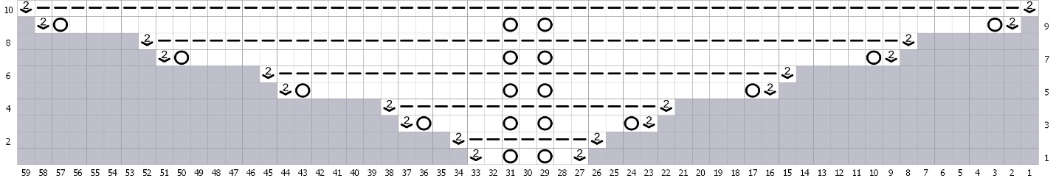
CHART A

EYELET ROW – This is optional - You can add 1 or many eyelet rows, randomly or at defined intervals. Eyelet rows are added on a RS (knit) row.

Written instructions for Eyelet Row
R1 kfb, yo, k1, (yo, k2tog) to marker, sm, yo, k1, yo, (ssk, yo) to last 2 stitches, k1, yo, kfb.
R2 kfb, P to last stitch, slipping marker in the middle, kfb.

Continue in pattern established in CHART A

EYELET CHART B
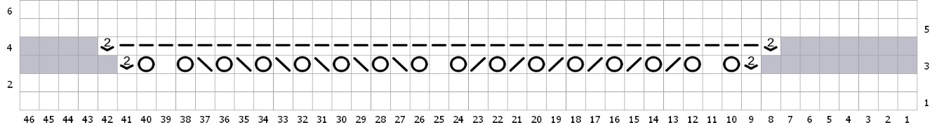

EDGINGS
The simplest edging is the picot cast off depicted in Fichu 1
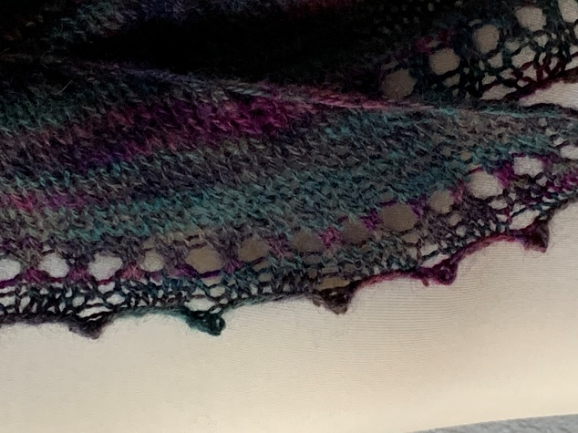
This is a 2-stitch picot that creates a slightly lacey cast-off. The edging takes approximately 0.2-0.3 oz of qiviut.
If you have 1 oz of qiviut, begin the edging after about 62-64 rows. An easy way to count this is to count the center holes – each hole represents 2 rows so 31 holes = 62 rows/32 holes = 64 rows. When to stop depends on how tight or loose your gauge is and amount of yarn left.
If you run out – you can use any yarn of a similar weight. Choosing a contrast color adds splash of color.
The following link provides a detailed description and video of the picot bind off (There are lots of video tutorials on picot cast off so pick one that works for you). https://donnajonesdesigns.co.uk/2020/07/19/picot-cast-off-tutorial/
In the basic picot cast off, you cast on 2 stitches using the cable or knitted cast on, then cast off 4 stitches (the 2 cast on stitches plus 2 more from the right-hand needle).
In fichu #1 – the binding uses a 2-stitch picot (cast on 2 st) with 5 stitch interval, therefore bind off 7 st. the edging starts with a picot..
Working from the wrong side, cast on 2 stitches using the cable or knit cast on, cast off 7 stitches, place the last stitch remaining on the right needle back on the left needle – repeat.

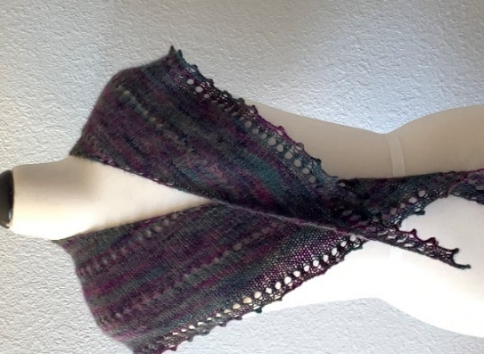
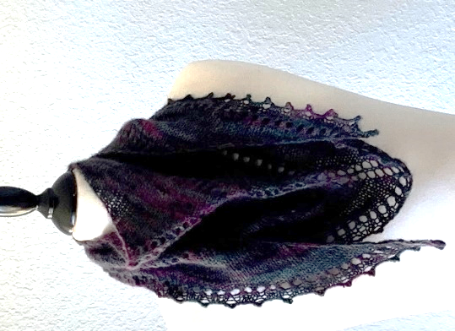
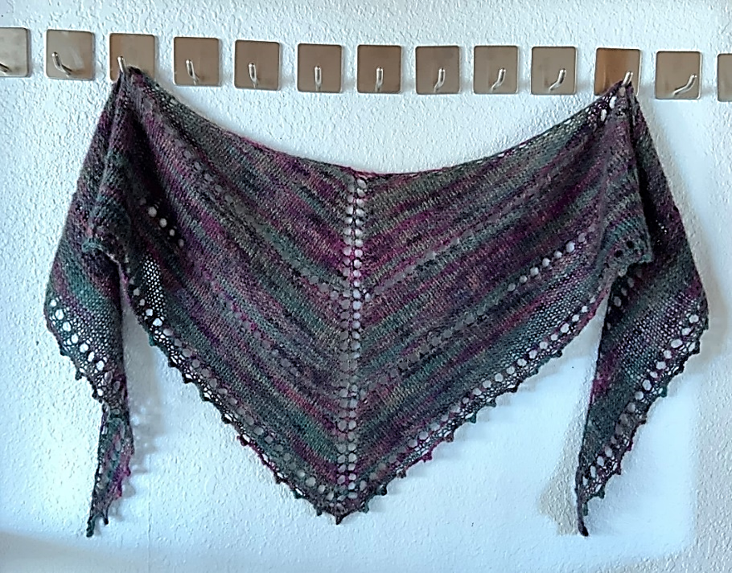
FICHU #1 has a plain picot edging and was knit with fingering weight yarn

PICOT EDGING WITH BEADS
Instructions for the picot are the same as above. We have used a crochet hook beaded bind off, a preferable technique to pre-stringing beads when using qiviut.
Working from the wrong side CO 2 stitches using the knitted cast on, place bead on this stitch – slip a bead onto the crochet hook, hook the last cast on stitch, slip the bead off the crochet hook onto the knitted stitch and replace stitch on the left needle.
Bind off: k2, *pass the first stitch over the second stitch, K1, repeat from * 5 more times (total of 7 cast off st). Return remaining stitch on right needle to left needle and repeat sequence to the last st. It doesn’t really matter if you are short a few stitches at the end. However if you want to ensure you have a bead on the point of the triangle, at about 4” before the point count the remaining stitches. You can shorten or lengthen the next few intervals by a stitch to ensure the picot falls on the point. Remember to count by 5 (or whatever interval you are using) and not by the total number of cast off stitches.
This link provides a simple pictorial of the process (using a 3 stitch picot and 4 stitch interval).
https://knotions.com/tutorial-beaded-picot-bind-off/
This link provides a very good video tutorial for adding beads to knitting in general by using a crochet hook.
https://www.youtube.com/watch?v=ODE3c1WM4bs

FICHU #2
Beaded picot with a 2-stitch picot and 4-stitch interval
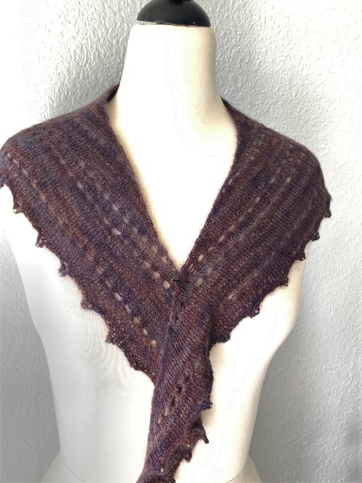
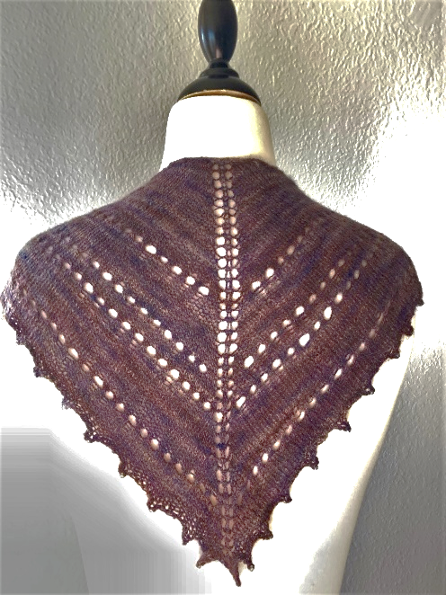
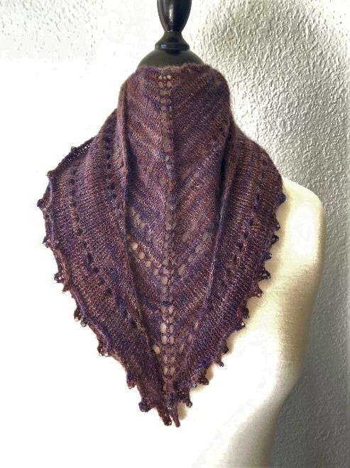

FICHU #3 Beaded Picot edging
Beaded picot with a 3 stitch picot and 5 stitch interval

