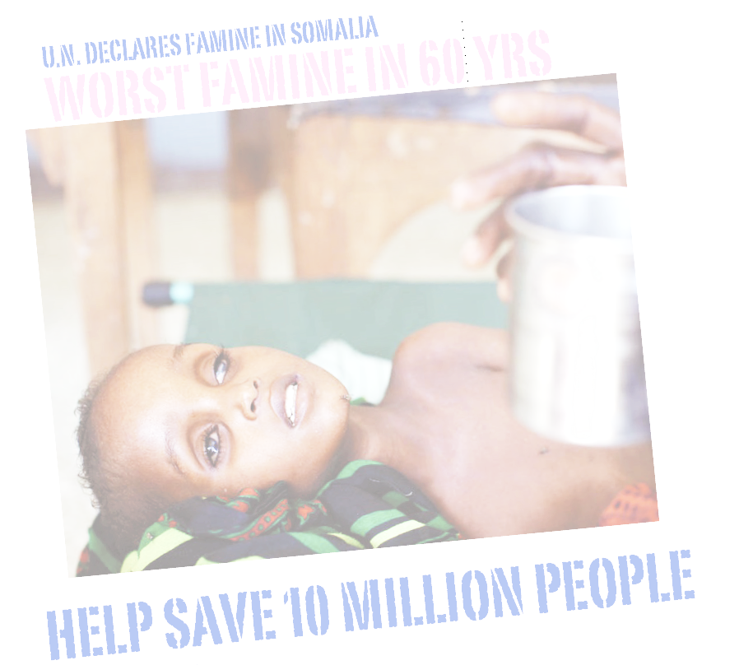
AN URGENT PLEA FOR HELP WITH FAMINE IN SOMALIA

Dear Friends:
The disastrous famine situation in Somalia is deteriorating at an increasing rate, and it is adding more to untold human suffering, unwanted deaths, and violent militants are on the rise. About 2.5 million Somalis, victim of the worst drought in 60 years, are in dire need of food, shelter, and medicine in order to survive the current famine. The United Nations has declared a famine in Somalia, a term reserved for only the most desperate food shortages.
Out of desperation, many malnourished Somalis are trekking a torturous journey upwards of three to four weeks in search of food, safety, and shelter at refugee camps. The United Nations has estimated that 10 million people, many of whom are women and children, now face the prospect of starvation in Somalia, with reports of tens of thousands already dead. We now face a disaster worse in scale than the earthquake Haiti, or even the 2004 Indian Ocean Tsunami. It is critical that the international community respond with food and medical supplies immediately.
Please show solidarity and come forward with an extended helping hand to help save the suffering humanity in Somalia. Donations go directly to the beneficiaries $1 = $1, and it will help 50,000 people in Somalia.
Ataur R. Chowdhury, Faculty Advisor, MSA
On behalf of,
MSA, ASA, OMAF at University of Alaska Fairbanks

Fundraising Event @ UAF Wood Center Ballroom
Saturday, October 27, 2011
5:00- 7:30 pm

Please donate to: The African Future (TaF)
Donate online: http://theafricanfuture.org/blog/?page_id=19
Donate at Wells Fargo: Account# 226002600208

Media Information:
Once kidnap victim in Somalia, she returns to help: http://today.msnbc.msn.com/id/44026902/ns/today-good_news/%20
CNN covered first Convoy of Hope by TaF: http://www.cnn.com/video/?/video/bestoftv/2011/08/08/exp.ac.somalia.lindhout.cnn

