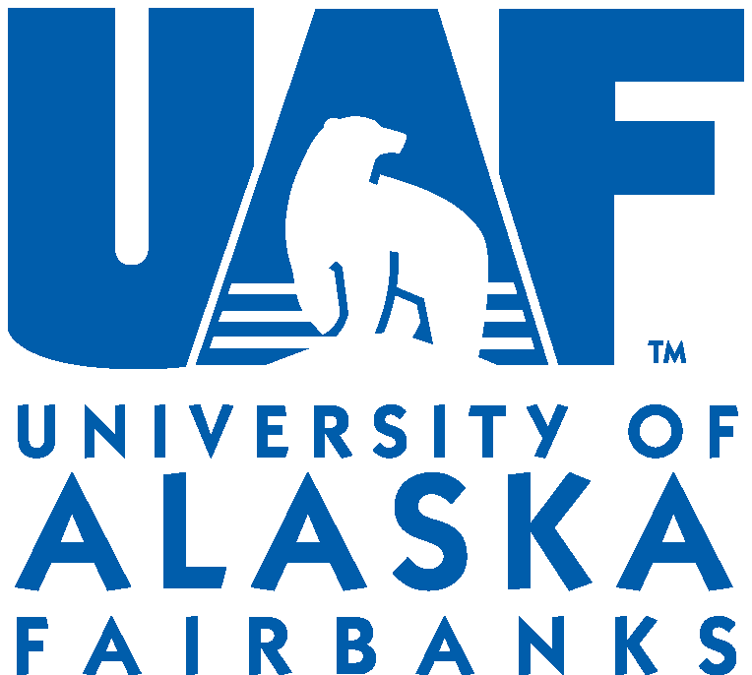

People’s Endowment Grant Application - 2012

Proposal due date: April 9, 2012

Thank you for submitting your project to the People’s Endowment board for grant consideration. Please fill out this form completely and include all necessary attachments. Successful applicants will be notified as soon as possible.

Name of group or department requesting funding:

Contact name and contact information:

Email: Phone:

For student groups, please provide a faculty member contact:

Faculty Member Email: Phone:

Title of project in need of funding:

Dates of project:

Description of project: (please attach a 2-3 page description of the project as well as the impact it will have on the campus community.)

Project budget: (please attach a simple but descriptive budget for this project)

Other sources of funding already secured and amounts:

Other sources of funding that have been sought:

When submitting proposal, please email to jahoppough@alaska.edu or mail to the following address:

UAF Provost Office
P.O. Box 757580
Fairbanks, AK 99775

Proposals can also be dropped at the UAF Provost Office in Signers’ Hall room 311. For questions, please feel free to contact the Provost Office at 907-474-7096.

