Beth Leonard
Associate Professor of Indigenous Studies
Center for Cross-Cultural Studies
University of Alaska Fairbanks (UAF)

2013-14 Fulbright Fellow
Host Institution: Victoria University of Wellington (VUW)

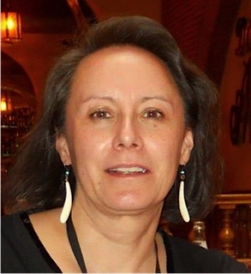

Getiy ngiłnath ts’i xiduxodinigi’anh  (I am trying to learn for a very long time) | Understanding Maori and Indigenous spaces at tertiary institutions in Aotearoa (New Zealand)

Beth Leonard is Deg Hit’an Athabascan and member of the Shageluk Tribe of interior Alaska. During Leonard’s fellowship at VUW from February-June 2014, she will co-instruct “Indigenous Knowledge[s] and Science” with her faculty host, Ocean Mercier; this videoconference course will include students from VUW and UAF.

Leonard will conduct collaborative, participatory research on the development and enhancement of Māori and Indigenous spaces at VUW, with the vision of strengthening Indigenous programming at UAF. She will also explore possibilities for future cross-institutional teaching and research collaborations between UAF and VUW.

Leonard is the fourth Alaska Native to earn a PhD from UAF. This Deg Xinag phrase coined by Leonard’s father, an Athabascan Elder, on the eve of her graduation captures the essence of her PhD and faculty journey in that she is still “trying to learn” and that this process will go on “for a very long time.”

