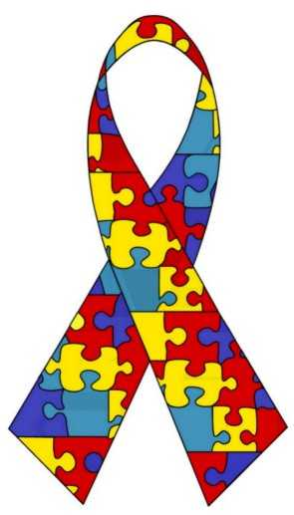
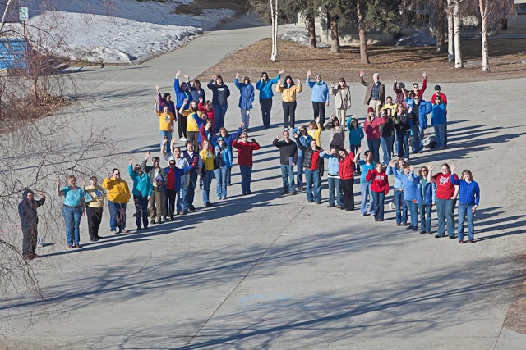
P
Join the FLASH MOB and
COME help us make a BIGGER ribbon

Autism Society of Alaska,
School of Education & Music Students
Tuesday, April 1st @ 1:00 pm

Meet between Gruening & Constitution Hall

Todd Paris will be filming and photographing

Consider wearing dark blue, bright blue,
yellow or red!

www.asagoldenheart.org

