Invest in our Future. Double your Dividend.
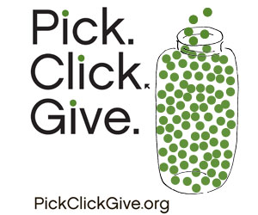
Did you realize the the deadline to file for your Permanent Fund dividend is Monday, March 31?
Pick.Click.Give by March 31st and be entered to win an EXTRA PFD! Ten lucky Alaskans who share part of their PFD will win an extra dividend!
As an Alaska resident, when filing for your PFD, you have the option to make a charitable donation to the University of Alaska Fairbanks. Giving to UAF via the Pick.Click.Give. program supports students and the university. Alaska residents like you can help students to achieve their goals through research opportunities, scholarships, fellowships and much more.
Already applied for your PFD? You can update your designations through August 2013!
Double your contribution! ExxonMobil has again generously offered to match gifts to Alaska colleges and universities via Pick.Click.Give. Every gift to any of the campuses of the University of Alaska will be matched one-to-one up to $100,000.

Click the image above for a short UAF Pick.Click.Give video.

The University of Alaska Fairbanks is accredited by the Northwest Commission on Colleges and Universities.
UAF is an affirmative action/equal opportunity employer and educational institution.

