Alternative
Spring Break Fundraiser


Finals getting you down?
Got a sweet tooth?

Get some Krispy Kreme Doughnuts!*

Preordering now!
$14/dozen
Go online at www.uaf.edu/leadership
Visit the LIVE Office or call 474-1170

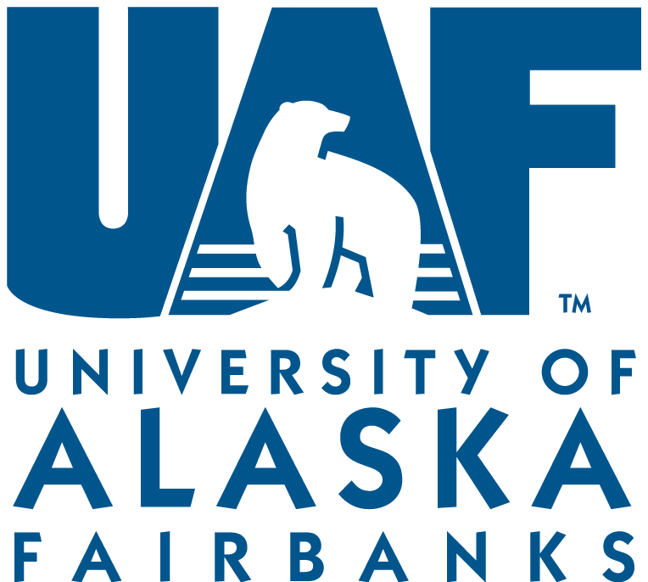
UAF is an AA/EO employer and educational institution.
*Doughnuts will be flown overnight & arrive December 9th

