


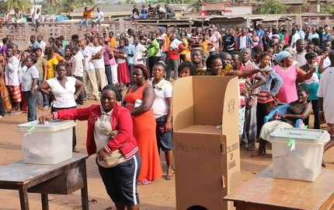
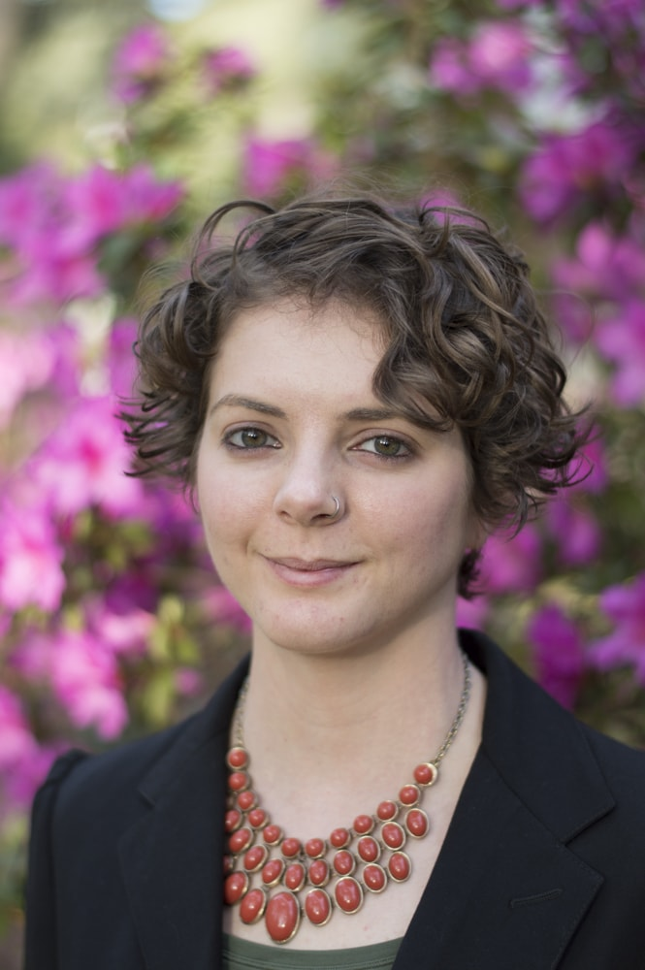

The Democratic Benefits of Centralized Institutions in Ghana

A Free and Public Lecture by: Dr. Jennifer Boylan
Room 303, Gruening Building
Presented by the Department of Political Science
College of Liberal Arts, University of Alaska Fairbanks
Tuesday, March 7th
^{5:00pm-6:30pm}

