Conducting research on state land:
Securing proper authorizations so your research site doesn’t inadvertently become a gravel pit

Murie Auditorium
Wednesday, October 19, 2016
3:30 - 5 pm
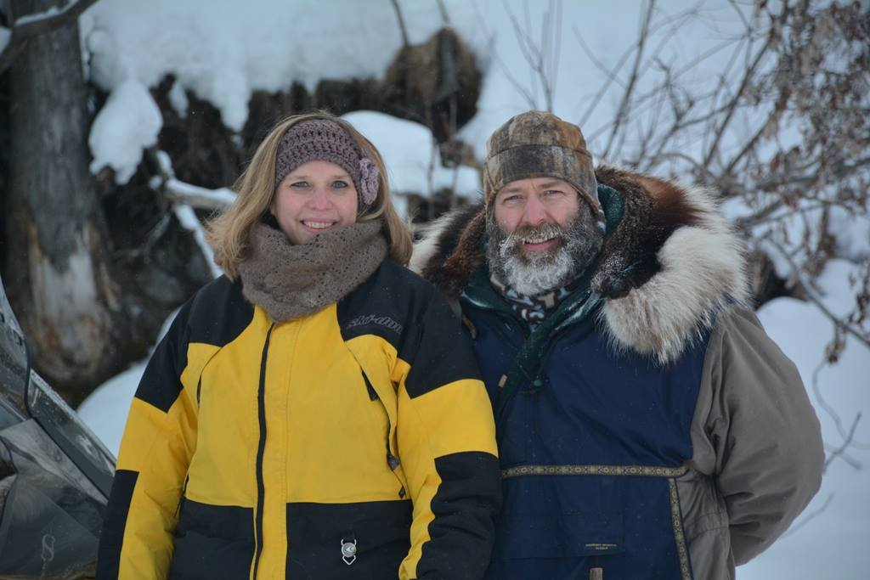
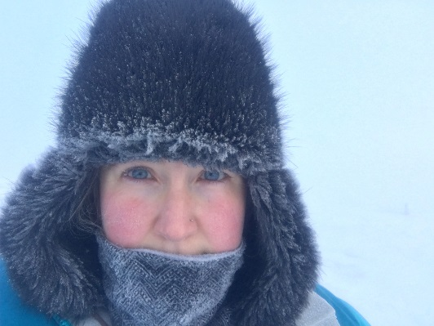

Kimberley Maher, Ph.D., Natural Resource Specialist, Alaska Department of Natural Resources, Division of Mining, Land, and Water (left photo)

Dian Siegfried, Real Property Specialist, UA Facilities & Land Management (right photo)
Approximately 25% of land in Alaska is state-owned. Much of this ~90 million acres, which includes land under navigable and public waters, is managed as General State Land for multiuse, including academic research projects and sites. Often, the permitting process is swifter and less cumbersome for authorizing research sites on state land, compared to federal land.
This seminar is designed for researchers—from PI’s to graduate students— and will address:
- types of state land in Alaska
- what is allowed on state land under Generally Allowed Uses
- Alaska Mapper, DNR’s online mapping program and geodatabase
- when an authorization is need to conduct research on state land (e.g. land use permit, special land use permit, and/or lease), and
- how to successfully navigate the application process through both the UA Facilities & Land Management office and DNR
A Question & Answer session will follow.

