Dear Students:
The Office of the Bursar would like welcome you to the new school year. We would like to share some information with all campus commuters to help make parking on campus easier for everyone. We are also taking this opportunity explain recent changes to UAF parking and to explain the new options to pay for parking
As you may know, there are multiple parking kiosks throughout campus where you can buy parking passes. These kiosks are designed to integrate online payments, debit/credit, and coins to ensure that everyone has access to UAF facilities. You can purchase a parking pass for regular decal required lots up to a month at a time. The passes purchased at kiosks in regular decal required lots such as Nenana do not permit parking in the pay-by-plate lots such as South Eielson or Signers Hall.
The kiosk located at the North West corner of the Bunnell building as well as the online program https://ppprk.com/park/ can provide parking permits for the two pay-by-plate lots. These lots (Signers and South Eielson) are designed to provide easy access to campus facilities and have a three-hour time limit. Individuals requiring more time are encouraged to park in a decal required lot and take one of the many campuses provided shuttles.
As a reminder, Gold Decal lots are reserved for those individuals with active Gold Decals and parking in these lots is strictly enforced. Meters are still used throughout campus in areas generally requiring parking for less than two hours. Feel free to use any open meter, but remember pay-by-plate does not cover meters unless they are specifically marked as handicap spaces. Once the time limit expires, additional payment is required as your decal is not a substitute this payment.
Do you know where your parking dollars go? Revenue from parking passes, temporary permits, citations, and meters fund the upkeep of parking on campus. The parking department helps fund Facilities Services' efforts to keep the lots clear of snow and properly maintained year round, to provide electricity to head bolt plugs, and to allow students, faculty, and staff to ride the borough bus free of charge with their Polar Express card. Parking Services also provides vehicle unlocks and jump starts free of charge to help campus members stay on the move!
If you have any questions, suggestions, or concerns, please feel free to email parking services at uaf-bursar@alaska.edu with parking in the subject line, or stop by the Bursar’s Office Monday through Friday, 8:00 am to 5:00 pm. The following page has a list of frequently asked questions along with their answers to help clarify any common parking questions that you may have. We wish you the best this fall, and Go Nooks!
Best Regards, Parking Services

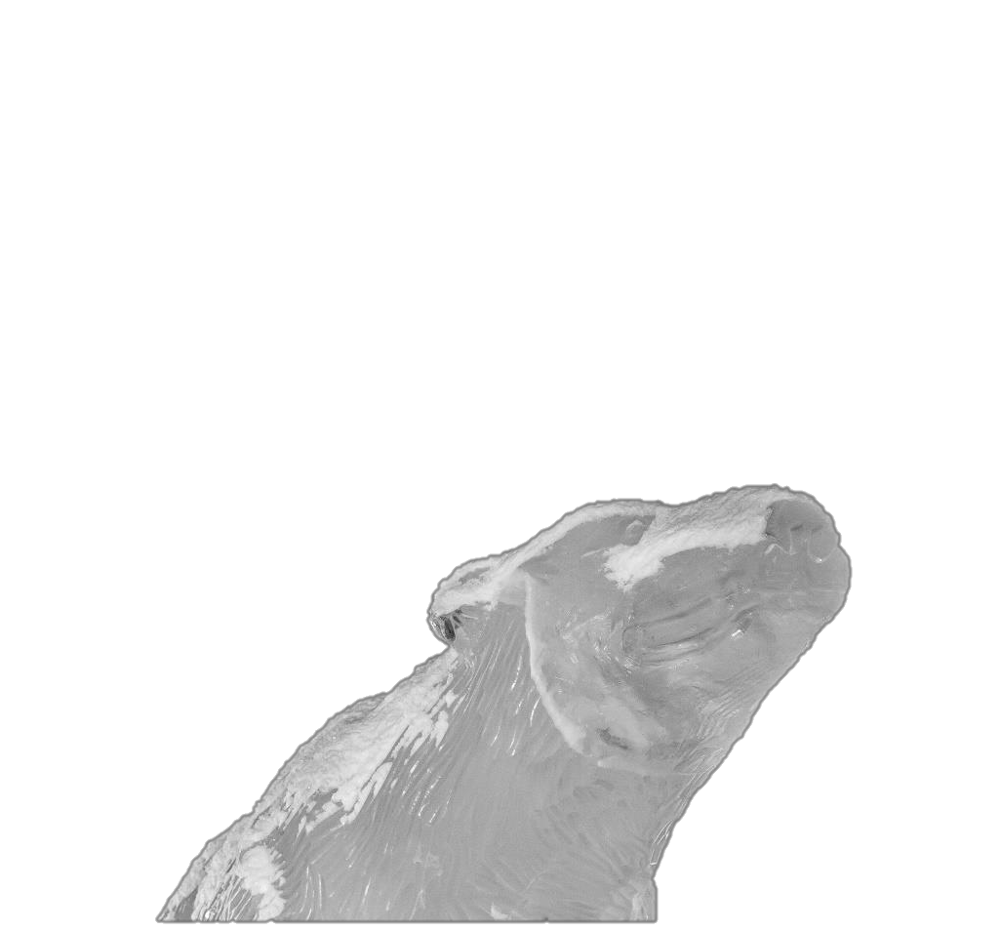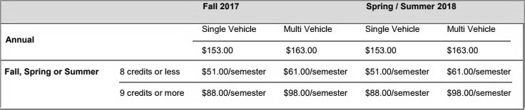FAQs

Can I use the pay-by-plate system to park in a metered space? No, pay-by- plate is not a meter substitution. If you park in a metered space, the meter must be paid.

- Can I park in a meter or pay-by-plate parking space with a decal or temporary pass? No, decals and temporary parking passes do not permit free parking in pay-by-plate or meter spaces.

- Can I park in the Gold Lots before 7 am, after 5 pm, or on weekends? Yes, Gold Lots are strictly enforced Monday-Friday 7am-5pm, but are available to everyone nights and weekends!

- How do I get a gold decal? Anyone can purchase a gold decal, although it is more expensive. If you would like to be put on the waiting list, a link can be found at the Bursar web page.

- Can I be ticketed for parking out of the lines, sideways, etc.? Yes, in an effort to accommodate everyone in the lots we ask that you ensure your vehicle is parked straight, and between the lines. We understand that the winter snowfall can cover the lines, however when the lines are visible, please park in the designated spaces

- Can I park in reserved or facilities spaces at the SRC/Patty gym after hours? No, Facilities Services and authorized only spots are not available to students, staff, or faculty on weekends or after hours. Facilities Services, CSO, police, and fire vehicles need access to these spaces 24 hours a day.

Student Prices

