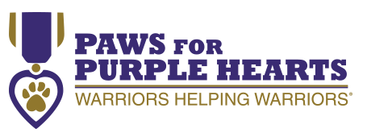
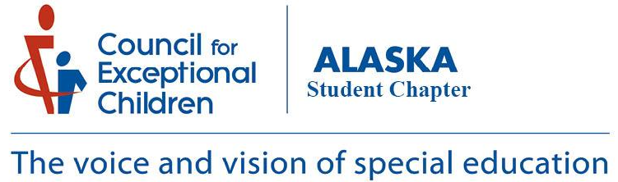

COMMUNITY EVENT
November 18th @ 10:30-12 @ University Park Bldg. Room 160
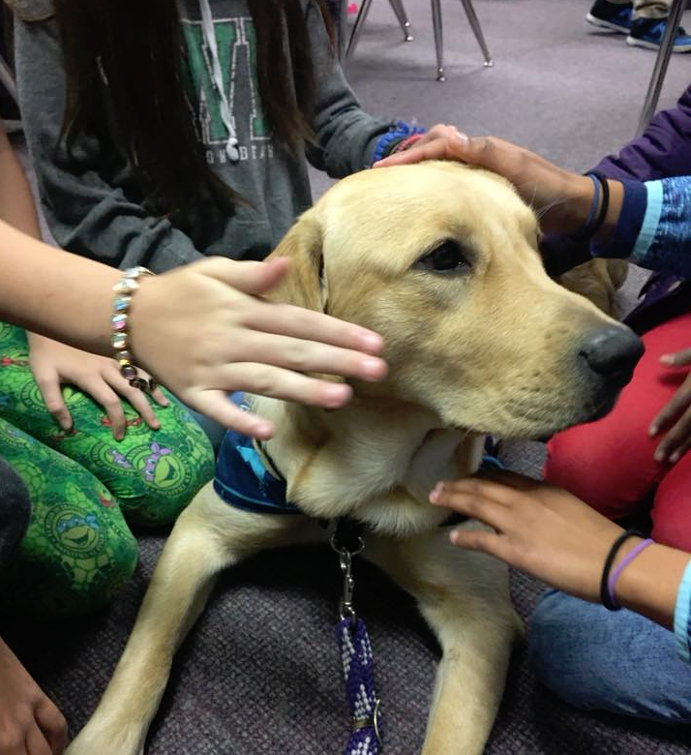
To Meet Betsy, Nathan and the Amazing Service Dogs

