The leaves may be falling, but your bank account doesn’t have to!

Budgeting

  - Workshop

Let’s AUTUMN-ate you a budget! UAF is partnered with Wells Fargo and they’re here to help you with budgeting strategies!

Where: Gruening 402

When: September 26

Time: 1-2 pm
For questions, contact Financial aid Office uaf-financialaid@alaska.edu or 474-7256
UAF is an AA/EO employer and educational institution and prohibits illegal discrimination against any individual: www.alaska.edu/nondiscrimination/.


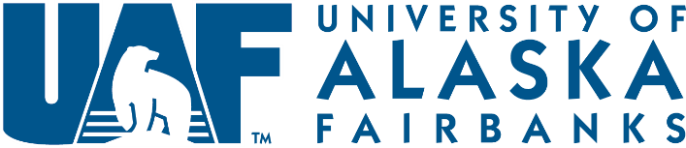
Free! No registration required

