Do not be spooked by credit!
Treat yourself to a free info session

Understanding

Credit
October 24 1pm-2pm
Gruening Room 402
Bring your lunch!
Open to all UAF students, faculty and staff.

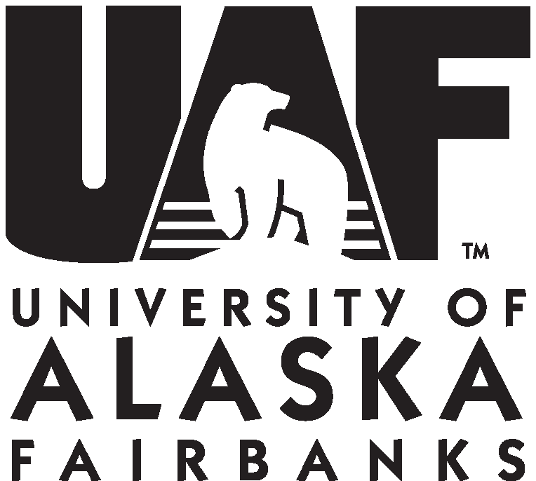
UAF is an AA/EO employer and educational institution and prohibits illegal discrimination against any individual:
www.alaska.edu/nondiscrimination/

