For questions, contact Financial aid Office uaf-financialaid@alaska.edu or 474-7256 UAF is an AA/EO employer and educational institution and prohibits illegal discrimination against any individual: www.alaska.edu/nondiscrimination/.

 | 

Retirement

Savings

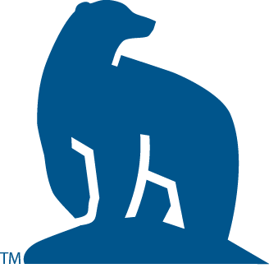

Saving for Retirement
Monday  February 10th  Dine 49  5-6pm |  | Thursday  February 13th  Gruening Room 301  1-2pm |  | Thursday  February 20th  CTC Room 305  6-7pm
Back again by popular demand!
UAF has partnered with Wells Fargo to bring to you more retirement workshops! Getting old is never fun, but it could be if you prepare!
 |  |  | 