December 17, 2020

The Division of Student Affairs at the University of Alaska Fairbanks is committed to supporting the success of first-generation college students. Serving as the Vice Chancellor for Student Affairs and speaking as a first-generation college student myself, I am pleased to support UAF’s application to the First Forward recognition program.

Within the Division of Student Affairs, we are focused on cultivating co-curricular experiences that aim to holistically develop scholars and leaders. Programs like New Student Orientation begin building community among first-generation students, faculty and staff through intentional programs like the First-Generation Breakfast. The Nanook Diversity and Action Center partners with our TRiO colleagues to raise awareness of first-generation students through our First Gen AK initiative and we celebrate their success at the First Generation Cording Ceremony each spring. We have committed funding to continue to support these existing initiatives and we are allocating resources to ensure new initiatives will be successful.

As student affairs professionals, we recognize the impact that higher education can have on the trajectory of a student’s life, especially in a state below the national average in regards to the percentage of the population holding a bachelor’s degree or higher. While UAF is a world-class research institution with a global impact, the communities we primarily serve in interior and rural Alaska lag well-behind the rest of the country in degree attainment -- just 16% of adults in interior, west and northern Alaska have achieved a bachelor’s degree or higher.

As Vice Chancellor for Student Affairs, I fully support this application to the Center For First-Generation Student Success’ First Forward recognition program and our entire division is committed to providing whatever resources are needed to support this effort and ensure the continued success of our first-generation college students.

Sincerely,

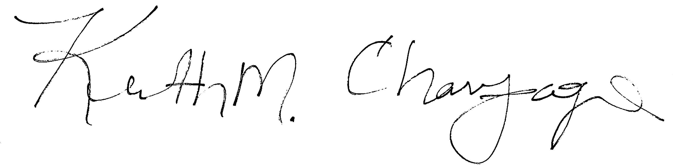
Dr. Keith M. Champagne
Vice Chancellor for Student Affairs
University of Alaska Fairbanks

