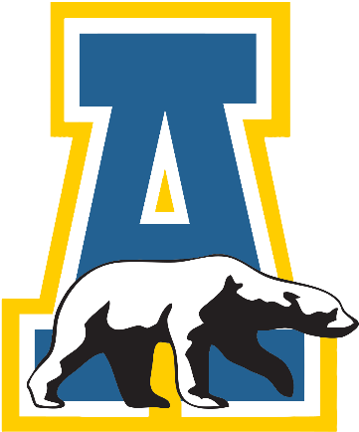
Community Exchange
University of Alaska Fairbanks

Current students, faculty, staff, retired faculty or staff, alumni, friends, and family of the University of Alaska Fairbanks.

Exchanging ideas, events, items, and support!

