All Travel Requests should be submitted through and approved in Concur, regardless of the funding source for the trip. R05.02.060(6)(e) Travel that is paid partially or wholly by third parties should follow the same approval and request process as university‐paid travel. All applicable travel regulations apply. There are many benefits to using Concur for all travel, including duty of care awareness, logging supervisor approval, and the clear identification of business travel.

How to fill out a $0 cost trip request:
Create a New Request and complete the header with your trip information including the name of the external funding source and the estimated amount they are paying. External funding sources includes self-funded business travel with no reimbursement.
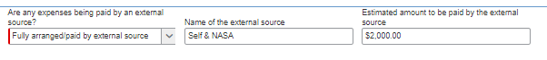
The funding source in the header can remain as the default funding on the traveler’s account. If no expenses are being paid by the university, then no information is entered in the Segments or Expenses tabs. Once the header is complete, Submit Request for trip approval.
Once the trip is complete, the request should be Closed/Inactivated. This will remove the request from the traveler's Active Requests. No expense report is needed for $0 cost travel.

If you have any questions please contact Rachel Jeppsen rjjeppsen@alaska.edu or Amanda Wall Amanda.wall@alaska.edu.

