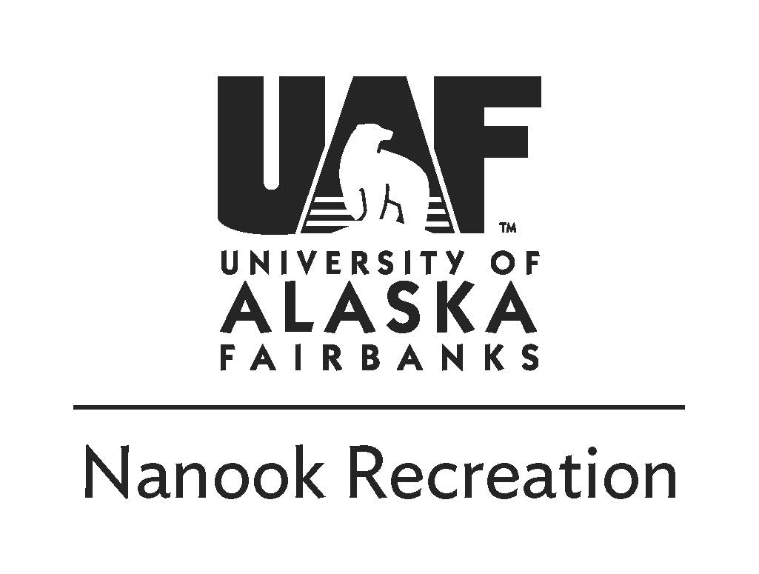
Ice Skating Adventure | 11.17.2019
UAF Students $20 Staff/Faculty $25

Sunday, November 17th
11:00am-Meet at Outdoor Adventures
11:30am-Arrive at Skating location (dependent on conditions)
3:00pm -Return to vehicles
3:30pm -Arrive back at UAF

Trip description:
We will go to an outdoor location to enjoy some ice skating on a frozen lake or pond. We will go to the Peat Ponds in Goldstream Valley, Creamers Field, or Tanana Lakes depending on conditions. OA will provide ice skates unless you want to bring your own. Dress for winter temperatures.

Things to bring:
- Ice skates (Provided by OA)
- Warm Wool Socks
- Daypack - to carry food, water, gear, and spare clothes for the day
- Warm (non-cotton) clothes
  - Synthetic or wool Base layer; top and bottom
  - fleece jacket / pants
  - Hard shell pants and jacket to repel water and wind
  - Puffy jacket
  - Warm hat
  - Winter gloves or mittens
  - Neck gaiter and/or face mask
- Lunch and snacks
- Water bottles (1-2 quarts/liters total)
Refund Policy:
Payment in full is required to sign up for a trip. A 100% refund is available if you notify the Outdoor Adventures Office of the cancellation more than two weeks (14 days) before the first day of the trip. Cancellation one week to 3 days (13 to 3 days) before the trip entitles the participant to a 50% refund. No refund is provided if the participant does not show up or cancels 2 days prior to the trip.

Safety and Risk Management:
Due to the nature of outdoor travel there are certain inherent risks in all of Outdoor Adventure’s trips. Acceptable risks include but are not limited to: winter temperatures, falling while skating. Conditions may include temperatures-20F or colder, snow, sleet, high winds and very low wind-chill. Driving risks may include slick, icy roads, poor visibility and wildlife. Alaska is a wild place - you need to take ultimate responsibility for your own safety as only you can. For your protection we require you to carry health insurance. You can purchase insurance for $2.60/day from the University (ask for details). All info is subject to change due to safety, weather, current conditions, etc.!
uaf-oa-staff@alaska.edu | 474-6027 | uaf.edu/recreation/outdoor-adventures

If you have any questions please contact us or visit our office in the SRC

