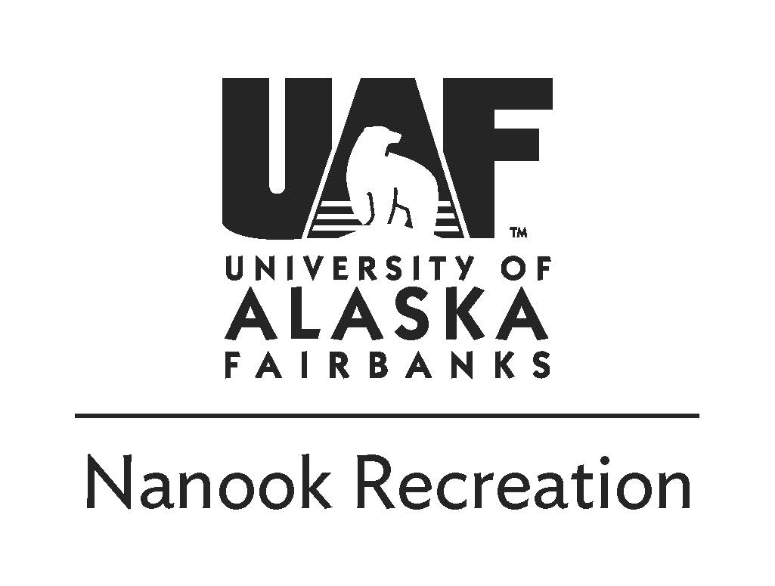
Denali Area Ice Climbing 2
12.5.2020
UAF Students $40 Staff/Faculty $50

Saturday, December 5th
8:00am -Meet at Outdoor Adventures
11:00am -Arrive at the climbing site and hike to the climbs
5:00pm -Return to vehicles and head back with a possible dinner stop
7:00pm -Arrive at UAF (later if there’s a dinner stop)

Trip description:
We will be ice climbing at Fox and/or Dragon Fly Creeks outside the Denali National Park boundary. This will be a great introduction for those new to the sport or a wonderful opportunity to improve your ice climbing skillset. We will be climbing on top-ropes using ice tools and crampons to scale a beautiful frozen Alaskan waterfall.

Things to bring:
- Double Plastic boots(Provided by OA)
- Crampons (Provided by OA)
- Helmet (Provided by OA)
- Harness (Provided by OA)
- Warm Wool Socks
- Daypack - to carry food, water, gear, and spare clothes for the day
- Warm (non-cotton) clothes
  - Synthetic or wool Base layer; top and bottom
  - Fleece jacket / pants
  - Hard shell pants and jacket to repel water and wind
  - Puffy jacket for chilly belays
  - 2 Hats, 2+gloves and mittens
  - Neck gaiter and/or face mask
- Lunch and snacks for a long day out
- Money for an optional grocery store stop ~$20
- Water bottles (1-2 quarts/liters total)

Refund Policy:
Payment in full is required to sign up for a trip. A 100% refund is available if you notify the Outdoor Adventures Office of the cancellation more than two weeks (14 days) before the first day of the trip. Cancellation one week to 3 days (13 to 3 days) before the trip entitles the participant to a 50% refund. No refund is provided if the participant does not show up or cancels 2 days prior to the trip.

Safety and Risk Management:
Due to the nature of outdoor travel there are certain inherent risks in all of Outdoor Adventure’s trips. Acceptable risks include but are not limited to; hiking over rough uneven terrain with a heavy backpack on, hiking up and down steep inclines with icy and loose footing, using sharp tools and crampons with the potential for personal injury and ice and rock fall while climbing. Climbers will be roped in and wear helmets during all climbing which may be as high as 70 feet. Conditions may include temperatures-20F or colder, snow, sleet, high winds and very low wind-chill. Driving risks may include slick, icy roads, poor visibility and wildlife. Alaska is a wild place - you need to take ultimate responsibility for your own safety as only you can. For your protection we require you to carry health insurance. You can purchase insurance for $2.60/day from the University (ask for details). All info is subject to change due to safety, weather, current conditions, etc.!
uaf-oa-staff@alaska.edu | 474-6027 | uaf.edu/recreation/outdoor-adventures

If you have any questions please contact us or visit our office in the SRC

