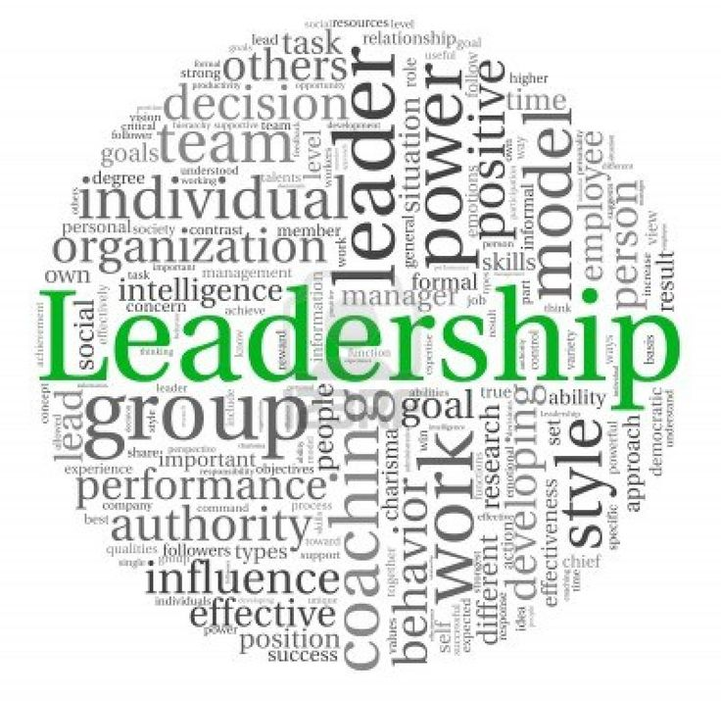
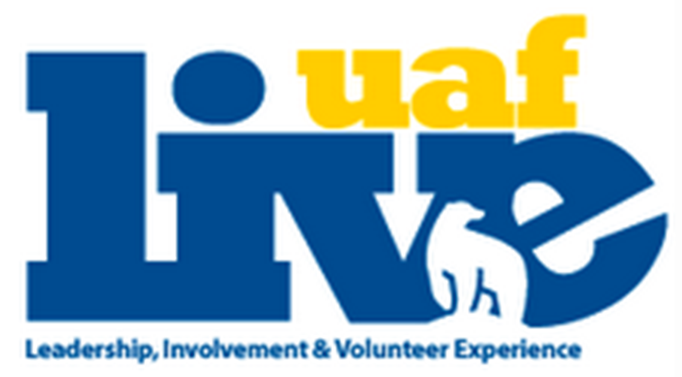
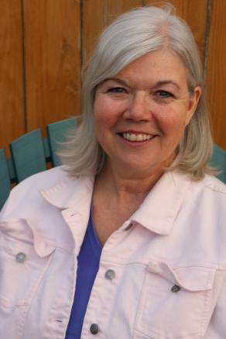
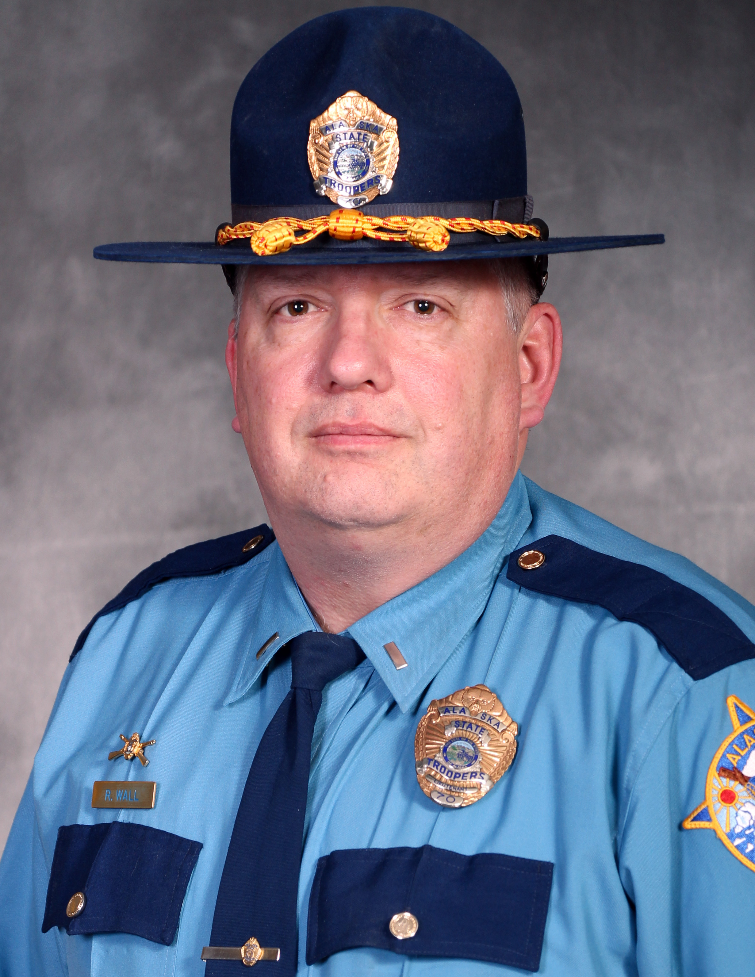

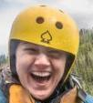
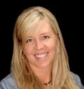
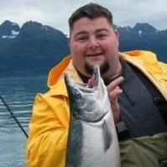
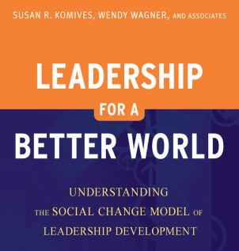
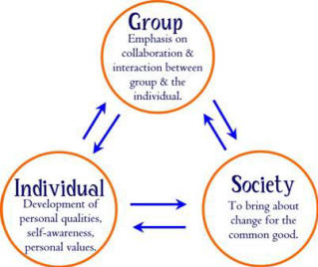
We foremost want to
thank you for coming to our annual leadership conference! We’d also like to thank our speakers, volunteers and the LIVE Office staff for helping make it a wild success!

9-945a – Registration/breakfast buffet

945-10a - Introduction of Social Change Model

10-1045a – Society Workshop Session 1

1045-1130a – Society Workshop Session 2

1130-1215p – Group Workshop Session1

1215-1p – Group Workshop Session2

1-2p – Lunch/Table Topics

2-245p – Individual Workshop Session 1

245-330p – Individual Workshop Session 2

330-4p – Closing message

Program:
  - October 25th, 9am-4pm, UAF Wood Center
L.I.V.E.
Lunch hour table topics!
UAF LIVE Office
P.O. Box 756640, Fairbanks, AK 99775
(907) 474-1170
uaf-leadership@alaska.edu
Want to speak with our presenters more? Look for them during lunch, each presenter will be leading an informal discussion on the material they presented. Enjoy!

Becoming a Lifelong Leader

UAF Leadership Conference 2014:
In 1989 I received a BA in Justice from UAF and was hired by the Alaska State Troopers in 1990. After several assignments I returned to Fairbanks and worked as a patrol Sergeant, Investigations Supervisor, Drug Unit Supervisor, Rural Supervisor and most recently the Deputy Detachment Commander in Fairbanks. Other collateral duties include a being the Team Leader for the Northern Special Emergency Reaction Team. In 2009 I graduated from Northwestern University School of Staff and Command. I own a millwork business and I am currently taking graduate courses from UAF seeking a MA in Justice Administration. I am also a coordinator for the AST Citizen's Academy here in Fairbanks.
I call myself a Positive-Changes-Coach because as a Leadership and Life Coach, I work with people who want to make a difference in the world. With coaching help, people can lead themselves to make those changes in their lives more easily, with a greater sense of well-being, and fulfillment.

Personal leadership – Terri Babers

Check out the book Leadership for a Better World by Komives and Wagner. Grounded in student experiences, this book includes student voices, stories, and contemporary case studies. Written in an informed and approachable tone, it provides a coherent set of guiding principles about how knowing oneself, meaningfully engaging with others, and adopting a systems perspective can promote the socially responsible leadership so needed in the world today.

Want to know more about the social change model?

Citizenship – Lt. Ronald Wall

Advocacy – Marylee Bates

“Societal sphere” speakers:

“Individual sphere” speakers:

“Group sphere” speakers:
I am devoted to carrying out the mission of Fairbanks Youth Advocates and passionate and knowledgeable about youth homelessness issues. I became aware of the issues surrounding students who drop out during my tenure as a Fairbanks North Star Borough teacher. I began volunteering at Fairbanks Counseling and Adoption’s street outreach program. Other agencies in the community were doing what they could to support this vulnerable population; the time was right for Fairbanks Youth Advocates to be part of the solution to youth homelessness.

Kaydee is the UAF Wellness Director and is responsible for the programming of the SRC; Intramurals, Personal Training, Group Fitness, Youth Day Camps as well as anything involving wellness programs for students.

Leadership Wellness – Kaydee Miller
I am the current Big Brothers, Big Sisters Enrollment and Matching Specialist. I have worked with kids and teens throughout my career. In church ministry I have had to wear many hats from fundraiser to program coordinator, counselor, therapist, and friend. I enjoy being able to manage volunteers and work to develop lasting relationships with all my volunteers and youth throughout the years.

Volunteering and Leadership – Jason Kempthorne
Keli Hite McGee founded Hites Consulting, Inc. out of Alaska in 2002. She has a Masters in Professional Communication from the University of Alaska Fairbanks (UAF). Keli provides executive coaching and consulting to leadership teams training them to increase employee productivity and accountability. She enjoys writing a business column in the Fairbanks Daily News-miner.

Leadership in the Workplace - Keli Hites McGee

Keli Hite McGee founded Hites Consulting, Inc. out of Alaska in 2002. She has a Masters in Professional Communication from the University of Alaska Fairbanks (UAF). Keli provides executive coaching and consulting to leadership teams training them to increase employee productivity and accountability. She enjoys writing a business column in the Fairbanks Daily News-miner.

This year’s conference is titled “Becoming a Lifelong Leader”. It is based on the social change model of leadership: that in order to be a successful leader you must operate in three different spheres of life: the individual, the group and society. Our conference is based on this model, providing workshops that focus on each sphere and address the characteristics of the sphere. The workshops will be lead by community professionals to provide not only an experienced presenter but also give the you the opportunity to network with these community members during the lunch break table topics.

About the conference:

Speakers:

